**The Political Economy of the Decline**

**in Antitrust Enforcement in the United States**

Filippo Lancieri

Eric A. Posner

Luigi Zingales[1]

October XXXX, 2021

*Abstract*. Antitrust enforcement in the United States has declined since the 1960s. Research suggests that, as a consequence, concentration has increased, as have price markups and corporate profits. We investigate the political causes of this decline in enforcement and consider three possible explanations: a decline in public support for antitrust enforcement, capture by special interests, and ideological changes among judges and regulators. We conclude that there was no public support for or endorsement of the weakening of antitrust enforcement—it was a technocratic decision made outside of the political process. In addition, we find that business interest groups were important drivers of the decline of antitrust enforcement, although the influence of business took many different forms. The conventional explanation for the decline of antitrust enforcement—the triumph of the Chicago school theory of antitrust—is at best incomplete. Legal reform under popular pressure will be needed to better protect US antitrust enforcement from private interests.

# Introduction

There is a growing consensus among economists that US industries have become more concentrated in the last 50 years and that this concentration has led to a significant increase in market power.[2] There is less consensus, however, on the cause of this increase. Some blame technology, others a decline in antitrust enforcement. Indeed, there is evidence that antitrust enforcement, whether through actions by the Federal Trade Commission (“FTC”) and the Antitrust Division of the Department of Justice (“DOJ”) or through private litigation, has decreased over time. The question is why.

The prevailing explanation is that Chicago School economists and lawyers were able to persuade the antitrust community that the law was too restrictive, and that enforcement was often unnecessary and even counterproductive.[3] This explanation assumes that ideas drive political change, ignoring any political economy consideration. By contrast, we focus on politics, starting with the observation that there is growing evidence that the policy of reduced antitrust enforcement was not neutral from a distributional point of view.[4] The declining labor share and the increasing profit share show that entrepreneurs and investors benefited more than workers and consumers from the change in antitrust priorities. In this paper, we study how these political economy considerations drove the evolution of US antitrust enforcement in the last sixty years.

A simple theory that business gets what it wants is obviously inadequate. Business has always been powerful in the United States, while the enforcement of antitrust law has waxed and waned at various times. Moreover, different businesses have different attitudes about antitrust law: some businesses (especially small or new entrants) support it, or at least take advantage of it, as Netscape did against Microsoft, and Yelp and Epic are doing now against Google and Apple. Large businesses, however, in general, oppose antitrust law, because they see it as an impediment to their own growth. Meanwhile, the public support for antitrust has fluctuated. Enthusiasm about antitrust law, driven by hostility toward monopoly and concentrated capital, prevailed in the late nineteenth and early twentieth centuries; at other times, the public has seemed indifferent to antitrust.[5] As a result, the explanation for the decline of antitrust enforcement is unavoidably complex and cannot be summarized by a simple statistical test.

Our starting point for understanding the decline of antitrust is the admittedly stylized premise that when policy is made with a high degree of public awareness through democratically accountable officials, the policy is more likely to advance public values and the public interest. In the U.S. system, the most democratically accountable officials are the members of Congress and the President. While they are, of course, influenced by interest groups like business, we assume that interest group influence is not complete; that it must overcome the influence of voters; and that the influence of voters is greatest when the policy in question has the attention of the public. In some cases, elected officials can bring the policy to the attention of the public, but in other cases, the public independently cares about a policy, and elected officials treat this public attention as exogenous.

Elected officials appoint and confirm judges and top regulators and, in the cases of most regulators, the president can fire them. Elected officials can also exert influence on judges and regulators by controlling budgets and jurisdiction. But we assume that judges and regulators enjoy some degree of autonomy from both the political class and the public, which they can use for good or ill—whose likelihood depends on the institutional structure of this power delegation. We also assume that regulators (and to some extent judges) face more complex incentives than elected officials do—for example, incentives arising from economic opportunities after their term is completed. We use this simple framework to organize our description of the decline of antitrust enforcement. Part I summarizes the data on the decline of US antitrust enforcement and associated winners, Part II describes our theory.

Part III is an empirical section, introducing different data that can help us grasp the motivations behind the pervasive changes in US civil antitrust enforcement over the past decades. Part III.A. focuses on actors subject to direct democratic accountability: the President and Congress. It first reviews all the major and broadly applicable antitrust statutes passed since the enactment of the Sherman Act in 1890 to assess whether these statutes promote or discourage stronger enforcement. We find that the weakening is not the result of direct Congressional action because almost all antitrust statutes encouraged greater enforcement. Voters may also express preferences for stronger or weaker antitrust enforcement through their elected officials. To address this pathway, we review (i) the political platforms of the two major parties in the presidential elections from President Roosevelt’s election in 1933 until 2020; (ii) the inaugural speeches; (iii) all State of the Union speeches; and (iv) all Executive Orders and Presidential Proclamations issued since 1933 to map out presidential positions on antitrust enforcement. Our findings are that while antitrust considerations were present in high-level political agendas until the Carter administration, concerns around monopoly and antitrust enforcement all but vanished afterwards—when most of the weakening in antitrust enforcement takes place. Part III.B then explores the mechanisms employed in the weakening of US antitrust enforcement over the past decades. It outlines the key role played by the indirectly democratically accountable regulators and courts as well as presenting data on environmental factors, notably the erosion of important pillars of FTC/DOJ independence, and shifts in the US Judiciary (impacting appointments and the exposure to certain economic ideas).

Part IV answers our motivating question by bringing together our theoretical framework from Part II and the data from Part III. Our preliminary analysis indicates that antitrust died a death by a thousand cuts that was not the result of democratic will—rather, it most likely reflects the influence of interest groups and ideas on institutions distant from democratic pressure: regulators and judges. Given the nature and pervasiveness of this undemocratic erosion, this process is also unlikely to fix itself absent a major legislative effort sustained by popular and civil society pressure—both of which are necessary to counteract an effective process of regulatory capture. A brief conclusion follows.

# Part 1: The Decline of U.S. Antitrust Enforcement and its winners

US civil antitrust enforcement has significantly weakened over the past decades. Vivek Ghosal studied Department of Justice enforcement actions (cases filed in court) between 1958 and 2002,[6] and identifies a number of structural breaks in enforcement dynamics taking place throughout the 1970s, all in the direction of weaker enforcement (as Figure 1 below shows). Ghosal defines a structural break as the Quandt Likelihood Ratio statistic that enables the separation, with a 15% trimming threshold, between two parts of the sample with different means. The estimated breaks took place in: (i) 1972 for total civil cases; (ii) 1974 for Clayton Act Section 7 Merger cases as a proportion of total US mergers; (iii) 1981 for Sherman Act Section 1 cases; and (iv) 1972 for Sherman Act Section 2 cases. These are represented in Figures 1(a)-1(c) below. However, these numbers likely understate the structural change, as they measure enforcement as the raw number of cases and not the number of cases divided by the size of the economy—which expanded massively this period, with real gross domestic product quadrupling from USD 4.9 trillion in 1970 to USD 19.2 trillion in 2019.[7] Figure 1(d), which shows the ratio of merger cases to total mergers, may offer a more accurate but equally grim picture. No matter where one looks, the overall downward trend in civil enforcement is unmistakable.

Figures 1a-1d – The decline in public antitrust enforcement actions[8]

However, Ghosal also finds a positive structural break towards increased enforcement in criminal cases, which takes place in 1979. While relevant, this data is not really comparable across time, however, because cartelization became a felony only in 1974, with the associated creation of a corporate leniency program in 1978 (though its effectiveness is contestable).[9] While our focus in this article is predominantly on civil, anti-monopolization cases that can impact market structure, a shift in policy towards the more aggressive prosecution of price-fixing is relevant. Virtually no one defends cartelization, and so it seems natural that as other forms of antitrust enforcement diminished, enforcement resources would be shifted to criminal investigations.

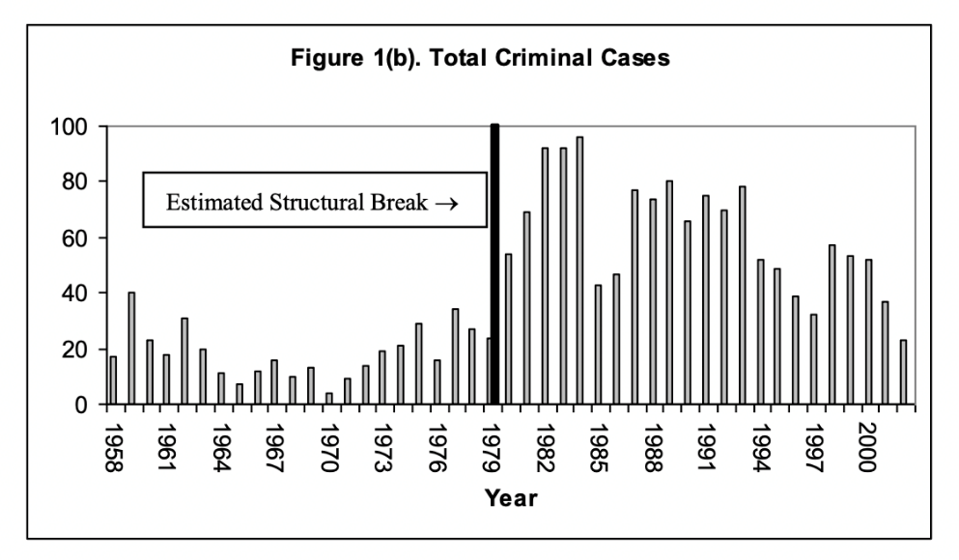

This conclusion that antitrust enforcement (except for criminal prosecution of price-fixing) has greatly diminished over the past decades is supported by other data. The number of private antitrust claims has dropped significantly from a peak in the 1970s and early 1980s.[10] This in part reflects Supreme Court decisions like the 1977 Illinois Brick ruling that limited the parties that qualify as potential plaintiffs in antitrust lawsuits.[11] This aggregate data also masks the extent of the real decline. First, it does not consider the significant expansion of the US economy in the period (mentioned above). If anything, cases should have risen for enforcement to remain steady. Second, it hides a similarly important shift within enforcement patterns, as cases against price-fixing arrangements, which represented only 10% of litigation early in the century, rose to almost 50% of all filings later on.[12] Third, antitrust enforcement was expected to take up the slack left by deregulation: as direct price regulation declined, government policy shifted to ensuring that markets were competitive through the indirect promotion of competition. As a result, one would have expected antitrust law litigation to go up, not down.

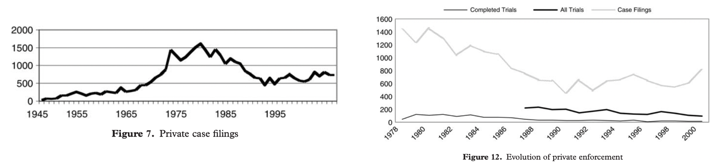

More recent data further corroborate this decline in enforcement. The fraction of mergers that are challenged by regulators has dropped dramatically in recent years; government non-merger civil complaints are down from their historical norms, with monopolization and other major Section 2 cases all but disappearing until 2020; and non-government civil antitrust litigation has decreased by more than 40% when compared to the already depressed benchmark of 2008.[13] Antitrust authorities are also facing important resource constraints. The antitrust division of the Department of Justice has approximately 25% less full-time staff today than it did a decade ago,[14] while the staff of the Federal Trade Commission has dropped by around 40% since a peak in the late 1970s.[15] US GDP grew approximately 40% since 2010, but the budget of the FTC and the DOJ Antitrust Division remains roughly the same,[16] leading to warnings that budget shortfalls may jeopardize enforcement actions.[17] A comparison with activities of European antitrust regulators shows how, in the past decades, antimonopoly enforcement has significantly weakened in the US.[18]

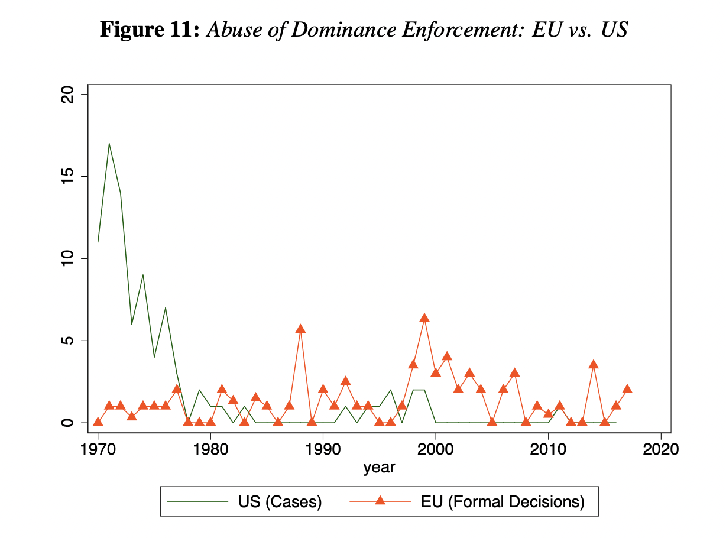

[the graph is hard to read in a black-and-white printout: adjust]

Taking all this evidence together, it is fair to say that non-price fixing civil antitrust enforcement is at one of the lowest, if not the lowest, points in the US in the past 100 years.

This weakening in antitrust enforcement is correlated with a steep increase in market concentration in the American economy, a fall in the labor income share, and increases in markups and corporate profits. Indeed, there is growing evidence that the production and distribution of goods and services in the U.S. economy has become more concentrated in the last decades. This trend was initially identified by Grullon et al. among American publicly traded firms,[19] but later confirmed for all Census firms (Autor et al.)[20] and Covarrubias et al.[21] By using U.S. NETS data, Rossi-Hansberg et al.[22] confirm the increasing trend in concentration at the national level but observe decreasing concentration at the zip code level during the same period.

As it is well known,[23] rising concentration is not necessarily an indication of growing market power: it could be the result of more efficient firms increasing their market share. To address this complication, De Loecker et al.[24] document that the weighted average markup of U.S. Compustat firms has risen from 1.1 in 1980 to 1.6 in 2016. These estimates have been challenged by Basu,[25] who argues that they are too high. Yet, Barkai[26] finds that the profit rate on American value added rose from 2.2 percent in 1984 to 15.7 percent in 2014. The markup ratio implied by these estimates rises from 1.02 to 1.19 over this period. Gutiérrez and Philippon arrive at similar estimates,[27] if we adjust for the fact that they report a markup on firm sales, while Barkai reports a markup on value added.

Rises in markups and concentration are correlated. Gutiérrez and Philippon[28] document that the aggregate Lerner index across all Compustat firms rises with the Herfindahl Index. Grullon et al.[29] find a positive correlation between changes in concentration levels and return on assets (ROA). When they decompose ROA, they find that the biggest factor behind the higher ROA is higher markups. Barkai[30] finds that industries that experience a larger increase in concentration also experience a larger decline in the labor share. Industry-level evidence in the market for beer,[31] kidney dialysis,[32] and mobile communication services[33] support the causal interpretation of this correlation.

As noted earlier, rising concentration and markups are not necessarily the result of lax antitrust enforcement.[34] As Autor et al. note, “If globalization or technological changes push sales toward the most productive firms in each industry, product market concentration will rise as industries be-come increasingly dominated by superstar firms, which have high markups and a low labor share of value added.”[35] While the ultimate origin of this increased markup is far from settled, there is increasing evidence that lax antitrust enforcement is at least partially to blame. For example, Wollman[36] finds that half of all proposed facility acquisitions in the dialysis market were not reported to the antitrust authorities, since they were part of mergers that fell short of the reduced size thresholds set forth in the 2001 Hart-Scott-Rodino Antitrust Improvements (HSR) Act. These unchallenged mergers led to higher prices and reduced availability of dialysis facilities, which caused 3.1 percentage point higher hospitalization rates and 1.6-2.0 percentage point lower survival rates in those markets. Alviarez et al. show that forcing divestitures in beer markets where antitrust authorities did not intervene would have reduced the beer price index by 14–30%.[37] Cunningham et al. find in conservative estimates that between 5.3%-7.4% of acquisitions in pharma markets are “killer acquisitions” to prevent future competition, and these disproportionately occur just below merger notification thresholds.[38] Finally, Blonigen and Pierce study the effect of mergers on markups by using plant-level data from the U.S. Census Bureau of Manufacturing over the 1997 to 2007 period. They find that markups increase between 15 percent to over 50 percent in acquired plants relative to non-acquired plants.[39]

In summary: US antitrust enforcement has surely declined over the past decades, both in absolute terms and relative to the economy. While debate remains over whether the decline has helped or hurt the economy, there is a growing consensus that this transformation had important distributional consequences. Increases in concentration have been associated with increases in profits and stock market value[40] and reductions in the labor share.[41] These distributional consequences are worrisome, as most American workers make no more today than they did forty years ago.[42] This increasingly solid connection between weaker antitrust enforcement, higher investor profits, wage stagnation and its negative consequences for workers and consumers means that this was not a welfare-neutral, Pareto improving technical decision. It was a political decision with potentially important distributive consequences, which in a democracy must be made under public scrutiny and in a democratically accountable manner.[43]

# Part II. A theory of regulatory change: direct capture, epistemological capture, and the Chomsky Effect

Understanding the political economy of changes in antitrust enforcement requires identifying what is a “political decision made in a democratically accountable manner”. Yet, this is complicated by the fact that fifty years after George Stigler’s article on the theory of economic regulation,[44] we still lack a comprehensive political economy theory of regulation.[45] This Part develops a simple but holistic conceptual framework that can help us analyze the available evidence.

Our starting point is the pressure group theory developed by Peltzman[46] and Becker.[47] Peltzman argued that politicians and public officials trade-off efficiency considerations and distributional ones when they make policy. This tradeoff is greatly affected by the initial conditions. Reducing competition in a perfectly competitive market leads to first-order profit gains and second-order consumer-surplus losses. By contrast, increasing competition in a monopolistic situation delivers first-order consumer surplus gains and second-order profit losses. Unlike Becker, however, we do not think that competition among pressure groups leads to efficient outcomes. In fact, the interest of the public is not adequately represented.[48] This does not mean that the public interest is always ignored. While business has always been powerful in the United States, the enforcement of antitrust law has waxed and waned at various times, likely as a result of the changing strength of the countervailing pressure groups and of the cohesion and strength of the business coalition as well. Some businesses (especially small or new entrants) tend to see antitrust enforcement as a net positive, while large businesses generally oppose it because it may represent an impediment to their own growth (at the very minimum). Many market characteristics impact these dynamics, such as how concentrated the industry is, how aligned are the political interests of industry players, how disperse the group paying the rent is, how opaque is the rent payment itself, transaction costs in the political organization of dispersed agents, among others.[49]

Tracing legislative and enforcement changes to particular interest groups by means of a single statistical test is likely impossible. Interest groups rarely act in the open (as their very involvement may electrify the opposition), and the impact of lobbying and donations on policy outcomes can be ambiguous. For this reason, we adopt an indirect approach. When elected officials act, they usually act publicly and thus become democratically accountable. Members of Congress vote for bills; the president announces policies and issues orders. Even when these actions are not reported in the media, political opponents can bring them to light in election campaigns—every action by an elected official creates a risk of public backlash if it does not please voters. This provides support for our identifying assumption that the locus and the transparency mode of a policy decision represent a proxy for the beneficiary of that decision: that is, for public officials directly accountable to voters (like Congress and the President) we assume that a decision is more in favor of the broader public if the public official openly advertises this decision in public speeches and campaign platforms than if not. This also permeates to specific mechanisms of action by these agents. For example, single-issue, ordinary legislation is more accountable to society and, as such, more likely to be aligned to voters’ interests than changes taking place amidst large, multi-topic omnibus bills (such as general budgets) or decisions taken through obscure processes in secondary Congressional Committees.

A different rationale must be employed to assess the actions of public officials who are only indirectly accountable to voters: Regulators and federal judges usually do not fear public retaliation in the polls,[50] but elected officials who nominate and appoint unpopular regulators and judges do, providing some form of indirect oversight. This means that once appointed, regulators and judges are relatively freer than elected officials to follow their ideological inclinations/personal beliefs in implementing policies or even to make decisions that benefit them personally, for example, by making themselves more attractive to future employers. This relative freedom reflects the specific characteristics of each position and the stringency of political oversight.[51] The existence of these processes changes incentives and shapes policymaking. On the one hand, transferring the decision to a body of experts only indirectly accountable to voters could be a way to hide this decision from the public, a move especially appealing when the decision is unpopular. On the other, one cannot presume that just because a decision is transferred to a more technocratic body, it is necessarily against the interest of the broader public, and neither do we—there are many efficiency reasons why technical decisions are delegated to experts.[52]

In general, interest groups can influence expert policymaking through at least three different mechanisms, which differ in how democratically accountable they are. The first, often highlighted in early public choice work, is that these groups can exploit regulators’ conscious acts to maximize their prospect of obtaining a well-paying job in the private sector after they leave government. This is the traditional revolving-door/lobbying mechanism through which firms “acquire” regulation. It is certainly not democratically accountable and has been documented in both the popular press[53] and in academia more generally.[54]

The second, which one may call “epistemological regulatory capture”,[55] reflects a process through which experts enact policies after being disproportionally exposed to ideas or data that benefit interest groups at the expense of the public. Epistemological capture can take place even in a world where experts are independent and well-intended, as special interest groups exploit large information asymmetries between industry and regulators to push their agenda. Theoretically speaking, it is a manifestation of Aghion and Tirole’s model of authority in principal-agent relations, in which a principal has formal authority to make a decision (the right to decide), but an agent has real authority (the effective control over the decision) because such decision requires information in the possession of the agent.[56] Interestingly, regulators know about this imbalance and can be generally suspicious about the information directly provided by companies. That is why interest groups rely on indirect mechanisms such as their control over datasets and influence over academics;[57] financial resources and donations to NGOs and think tanks,[58] control over human capital,[59] sponsorship of training programs,[60] and even influence over media coverage[61] to convince regulators that a decision that benefits the interest group is in the public’s best interest. Epistemological capture is unlikely to be democratically accountable, as it partially relies on control over information and discourse, but exceptions may exist. In addition, it is hard to detect—experts are usually acting in good faith—making it likely more pervasive but no less dangerous to general welfare than the traditional one.

The final mechanism is what we call the Chomsky effect,[62] or the process through which experts are disproportionally selected from a pool of people with an ideology that benefits special interest groups.[63] The democratic legitimacy of this system is tied to the legitimacy of the appointment process itself and the amount of public vetting involved: if the President or Congressional members campaigned on the topic, the expert was questioned about his views during the appointment process and/or was specifically appointed to implement specific policies, then this would be the type of indirect democratic accountability referenced to above. The opposite happens, however, if experts are appointed without a clear mandate or much public scrutiny, or even worse if they advocate for a policy during the appointment process but implement another once confirmed.

For all three mechanisms, the likelihood that special interests are successful is also tied to the institutional design of the system, which can facilitate or hinder this process. Capture is costly to the public—now forced to pay rents—and may lead to civil pushback. In order to overcome or prevent this, effective regulatory capture requires an investment by interest groups, who must spend money and other forms of political capital (e.g. mobilization of stakeholders, control over the media, engagement with academics, etc.) to promote their interests without raising awareness and/or enabling to such pushback.[64] The amount that must be spent (or the cost of this “influence”) increases when the design of the regulatory system incorporates institutional counterweights that help enable pushback.[65] Mechanisms vary per area and per jurisdiction, but in general one can stress the role of transparency rules (designed to promote public awareness and democratic accountability of regulatory initiatives) and the institutional capacity of the regulator (such as its ability to access independent resource sources and to maintain an independent and qualified civil servant body). The capture of transparent and accountable regulators is costlier because both processes enable opponents of interest groups to mobilize and counter their special influence.[66] The institutional capacity of the regulator also matters. A regulator that has independent funding sources and that can count on a well-resourced and well-compensated body of civil servants is more likely to resist interest group pressure than a weaker regulator. As we will discuss, most regulatory staff are paid less than they can receive in the private sector. This salary difference reduces regulators’ tenure and gives an enormous advantage to the regulated. Lawyers, economists, and accountants who join regulators early in their career will obtain inside knowledge as to the methods, priorities, and norms of the regulators—all akin to trade secrets—which they can bring to private-sector employers a few years later.[67] Because this inside information is valuable, and is also a good selling point for clients, former high-quality regulators are in great demand and can earn high salaries if they revolve the door to the private sector—the likelihood increasing the higher the pay-differential between the public and private positions. Structural deregulation, or “the systematic undermining of an agency’s ability to execute its statutory mandate” through practices such as “leaving agencies understaffed and without permanent leadership; marginalizing agency expertise; reallocating agency resources; occupying an agency with busywork; and damaging an agency’s reputation” can be an effective form of capture of a regulatory policy that is usually shielded from public scrutiny and accountability.[68]

Importantly, the framework proposed herein does not assume that regulators and judges necessarily (or even mostly) act against the public interest, or that elected officials always act in the public interest. Nor do we assume that regulators and judges are necessarily (or even mostly) motivated to please a particular interest group. There are innumerous examples of regulatory policies that increase overall welfare, and not all bad policy is “acquired” directly by the industry: incompetence and ideology also play a major role.[69] What we assume is that because politicians are themselves accountable to voters, this impacts their incentives to publicize (or not) the decisions taken by these experts: politicians are more likely to openly discuss/publicize technical decisions that have positive general welfare impacts than those that do not, which are better off shielded from the public eye. Our target is to understand democratic accountability, so our focus is on democratic scrutiny, usually associated with public attention, as a proxy for welfare impacts.

Putting all these theoretical considerations together, we make the following hypotheses: When a decision is made by a publicly elected representative, who publicly campaigned on it, we consider this decision to be in the interest of the public at large. If it is made by a delegated expert (judge or regulator), but it is claimed by the politician who appointed her as a success or is the explicit reason why the expert was appointed to begin with, we consider it less likely to be in the public interest than the above case, but more likely than the next possibility, i.e. a decision made by a publicly elected representative who does not openly advocate for it in an election or, worse, if shielded from public scrutiny by inclusion in general omnibus legislation or taken through obscure procedural shortcuts. Finally, the decision that is least likely to be in the public interest is the one made by a non-elected expert in a weak regulatory and non-transparent agency while no high-level elected representatives take credit for it.

# Part III. Antitrust reform and the democratic process

This framework provides us with the theoretical foundations to gather evidence that can help us assess what drove the weakening of antitrust enforcement in the US. This Part starts by providing data on the relationship between weakened antitrust enforcement and direct democratic accountability (Part III.A), examining first the interaction between the enforcement mandate and major antitrust statutes (Part III.A.1) and then the interaction between the enforcement mandate and Presidential political campaigns, speeches, and executive policy (Part III.A.2). It then provides data on the relationship between weakened antitrust enforcement and technocratic bodies (Part III.B.), first describing the role of experts in the weakening of enforcement (Part III.B.1), and then examining changes taking place within expert bodies such as the FTC and the DOJ (Part III.B.2) and courts (Part III.B.3).

## Part III.A. Weakened Enforcement and direct democratic accountability

### Part III.A.1 Antitrust Enforcement and Antitrust Statutes

Starting in the late nineteenth century, the United States Congress passed a series of statutes that shaped US antitrust enforcement. The most important laws include: (i) the Sherman Act (1890); (ii) the Clayton Antitrust Act (1914); (iii) the Federal Trade Commission Act (1914); (iv) the Robinson-Patman Act (1936); (v) the Celler-Kefauver Act (1950); (vi) the Antitrust Procedures and Penalties (Tunney) Act (1974); (vii) the Hart-Scott-Rodino Antitrust Improvements Act (1976); (viii) the Foreign Trade Antitrust Improvement Act (1982); (ix) the International Antitrust Enforcement Assistance Act (1994); (x) the updated amendments to the HSR of 2000 and (xi) the Antitrust Criminal Penalty Enhancement and Reform Act (2004)—which was later extended by the repeal of sunset provisions in 2020.

Virtually all these statutes expanded the scope of antitrust law and strengthened enforcement beyond the baseline antitrust regime created by the Sherman Act. The Clayton Act blocked specific anticompetitive practices, including price discrimination, tying, and mergers, and strengthened enforcement by creating a private right of action and a remedy of treble damages. The FTC Act created the FTC, a new independent agency, and gave it authority to enforce the antitrust laws. The Robinson-Patman Act targeted price discrimination. The Celler-Kefauver Act closed gaps in the Clayton Act’s restrictions on mergers. The Hart-Scott-Rodino Act strengthened merger enforcement by requiring large merging firms to give notice to the antitrust authorities and directing the antitrust authorities to review mergers ahead of their consummation. The Tunney Act strengthened judicial review of consent decrees and increased penalties for antitrust violations; the International Antitrust Enforcement Act facilitated cooperation between the US and foreign antitrust authorities; and, finally, the Antitrust Criminal Penalty Enhancement and Reform Act greatly increased criminal fines for corporations and prison sentences for individuals engaged in cartels and strengthened leniency programs to help detect violations.

Only two of the statutes provide exceptions to the pro-antitrust enforcement pattern, and these exceptions were limited.[70] The Foreign Trade Antitrust Improvement Act limited the rights of foreign victims of anticompetitive behavior to challenge that behavior in US courts. But while the law allowed American companies to commit antitrust violations overseas, Congress contemplated that those violations would remain subject to the domestic law of the affected foreign states.[71] Moreover, Congress made clear in the FTAIA that foreign-oriented behavior that caused harm to American markets remained subject to U.S. antitrust enforcement—that is, it did not envision a weakening of US antitrust laws in the domestic market.[72] The other exception is the 2000 Hart-Scott-Rodino amendment, which marginally raised the threshold for reporting mergers to the government. Yet, many public officials and commentators at the time justified the amendments as helping increase enforcement by relieving the FTC and the DoJ from dedicating an “ever-expanding portion of their resources to the [merger review] program”.[73] Moreover, the 2000 HSR amendment passed in the twilight of the Clinton Presidency (on December 21), as four pages buried within the 320-page omnibus bill for the Fiscal Year 2001 Commerce-Justice-State Appropriations Bill.[74] It is hard to see this law as an important, publicly transparent effort by Congress to weaken antitrust enforcement.

During this period Congress also rejected attempts to weaken enforcement by means of new legislation, as it is the case for the Robinson-Patman Act. Approved in 1936, the Act aimed to “protecting small business firms from competitive displacement by mass distributors at a time of general economic distress”.[75] Its repeal or substantial overhaul has been recommended at least four times, in 1955, 1969, 1977, and 2005.[76] In spite of all these attempts, the Robinson-Patman Act is still on the books. Interestingly, it is not enforced: public litigation fell from a peak of 758 cease-and-desist orders between 1960-1972 to all but zero in modern times.[77] This seems to be an example of experts overruling the political will expressed by elected representatives, resulting in disappearing enforcement.[78]

Finally, while the focus of this paper is federal antitrust enforcement, we should comment on state law. In the wake of the *Illinois Brick* decision, numerous state legislatures enacted so-called Illinois Brick repealer statutes, which created state law causes of action for the indirect purchasers whose claims were barred under the Supreme Court decision.[79] Otherwise, state courts tend to interpret longstanding antitrust statutes consistently with the interpretations of federal laws by federal courts. As a practical matter, this means that a state pattern of greater legislative but weaker judicial support for antitrust enforcement mirrors federal experience. However, a more detailed analysis of state antitrust enforcement is beyond the scope of this paper.

While the pattern of antitrust legislation in the United States is overwhelmingly in the direction of greater liability and enforcement, this trend peters out in the 1970s. All of the statutes after HSR were minor. Congress’ and (as we posit) the public’s attitude toward antitrust enforcement shifted from its post-Depression enthusiasm to something like indifference or neglect in the 1980s. However, we find no direct evidence by way of new legislation of congressional or public hostility to antitrust enforcement during the post-war period.

### Part III.A.2 Antitrust Enforcement and Presidential Political campaigns.

Statutes are not the sole source of direct democratically legitimate changes in policy. The president is an elected official with an independent source of power—the power to execute or enforce the laws. Virtually all candidates for the presidency make promises about how they will use this power by announcing their enforcement priorities, which they typically refer back to in speeches and orders after being elected. Accordingly, we ask whether the public endorsed the decline of antitrust enforcement by voting for presidential candidates who promised to reduce antitrust enforcement (or endorsed enhanced antitrust enforcement by voting for candidates who promised to increase antitrust enforcement). To answer this question, we collected and analyzed, for the period from 1932 to the present: (i) all the presidential campaign platforms of both Democratic and Republic presidential nominees; (ii) all presidential inaugural addresses; (iii) all state of the union speeches and Congressional messages; and (iv) all presidential executive orders and proclamations (for later).

The figure below consolidates the references to two key terms that are associated with antitrust enforcement: “antitrust” and “monopoly”.[80] Our goal is to understand whether these were politically salient topics that would trigger a democratically-backed major policy shift even in the absence of explicit changes to antitrust statutes.[81]

An analysis of inaugural and state of the union speeches reveals a pattern: antitrust and the fight against monopolies were a politically salient topic until the Carter presidency in the late 1970s (the exception being Presidents Lyndon Johnson and Nixon). However, both topics disappear from public addresses from the 1980s onwards, when most of the weakening of antitrust enforcement takes place.

**Source:** Inaugural speeches and State of the Union Addresses and Messages to Congress, as compiled by The American Presidency Project of The University of California Santa Barbara (<https://www.presidency.ucsb.edu>)

An analysis of these references shows bipartisan support for strong enforcement while antitrust was salient. For example, in his 1944 State of the Union Address, FDR stated “The right of every businessman, large and small, to trade in an atmosphere of freedom from unfair competition and domination by monopolies at home or abroad.”[82] In his 1948 State of the Union Address, President Truman affirmed that “[c]ompetition is seriously limited today in many industries by the concentration of economic power and other elements of monopoly. The appropriation of sufficient funds to permit proper enforcement of the present antitrust laws is essential. Beyond that we should go on to strengthen our legislation to protect competition.”[83] In 1961, President Eisenhower boasted how a “major factor in strengthening our competitive enterprise system, and promoting economic growth, has been the vigorous enforcement of antitrust laws over the last eight years and a continuing effort to reduce artificial restraints on competition and trade and enhance our economic liberties.” [84] In 1962, President Kennedy stated that “[t]his administration has helped keep our economy competitive by widening the access of small business to credit and Government contracts, and by stepping up the drive against monopoly, price-fixing, and racketeering.”[85] In 1976, President Ford would stress the need to foster competition and lower prices in sectors such as airlines, trucking, railroad and financial institutions, affirming that “[t]his administration, in addition, will strictly enforce the Federal antitrust laws for the very same purposes.”[86] Finally, President Carter, already responding to changes in Supreme Court doctrine starting to weaken enforcement, would affirm in 1978 that “[o]ur Nation's anti-trust laws must be vigorously enforced”,[87] and again in 1979 that “[f]ree enterprise and competition, protected by the antitrust laws, are the central organizing principles of our economic system. (…) These [historical] fines and sentences [of the past year] are significantly larger than in past years, and are consistent with my strong commitment to vigorous antitrust enforcement. (…) Under the Supreme Court's decision in the Illinois Brick Case only direct purchasers may recover, even though they may have passed on the injury to consumers, who are prevented from suing. This decision undercuts state and private enforcement of the antitrust laws, reduces their deterrent effect, may contribute to higher prices, and often allows the violator to keep his gain at the expense of the injured consumer.”[88] Therefore, if anything, the weakened enforcement that courts and other stakeholders start to promote in the late 1970s takes place *despite* a democratic will suggesting otherwise.

Not all Presidential priorities make the cut to be included in inaugural and State of the Union speeches. Another way for an administration to convey to the public its political priorities is to include them in the pre-election party platforms and in presidential executive orders and proclamations. Yet, an analysis of these documents reveals an even more interesting picture. First, following the findings above, antitrust enforcement was salient until the Carter Administration, but almost disappears afterward.[89] Indeed, from 1932 until Carter, the winning platform mentioned antitrust and monopoly an average of 3.7 times; after 1980, this number falls to an average 0.8 mentions.

**Source:** Presidential Party Platforms, as compiled by The American Presidency Project of The University of California Santa Barbara (<https://www.presidency.ucsb.edu>)

A more detailed analysis of each Presidential platform strengthens this conclusion by showing how throughout both periods references to antitrust are almost always towards *expanding* *enforcement and combating monopolies*. Indeed, antitrust is always mentioned in a positive way, and monopoly is always mentioned in a negative way. For example, the 1964’s Democratic Platform of President Lyndon Johnson stressed how during his presidency “The Federal Trade Commission has stepped up its activities to promote free and fair competition in business, and to safeguard the consuming public against both monopolistic and deceptive practices. The reorganized Antitrust Division of the Department of Justice has directed special emphasis to price fixing, particularly on consumer products, by large companies who distribute through small companies. These include eyeglasses, salad oil, flour, cosmetics, swimsuits, bread, milk, and even sneakers.”[90] Both the 1968 and the 1972 Republican Presidential Platforms promised vigorous antitrust enforcement, with the 1972 platform stressing that: “We will press on for greater competition in our economy. The energetic antitrust program of the past four years demonstrates our commitment to free competition as our basic policy. The Antitrust Division has moved decisively to invalidate those "conglomerate" mergers which stifle competition and discourage economic concentration. The 87 antitrust cases filed in fiscal year 1972 broke the previous one-year record of more than a decade ago, during another Republican Administration.”[91]

This pattern of positive mentions to antitrust and negative mentions to monopoly continues even after the 1980s. An interesting and rather unique case is the 1980’s election when Jimmy Carter lost his re-election bid to Ronald Reagan. Faced with rising inflation and a stagnant economy, Carter’s losing agenda focused on economic fairness, and strong antitrust enforcement earned a dedicated page in his 126-pages program. Yet, while Reagan ran on a small government platform, a key focus was the promotion of small businesses. Reagan’s platform never attacks antitrust enforcement; on the contrary, the Platform stresses how the deregulation of sectors such as transportation would require strengthened enforcement of antitrust laws: “[c]onsequently, the role of government in transportation must be redefined. The forces of the free market must he brought to bear to promote competition, reduce costs, and improve the return on investment to stimulate capital formation in the private sector. The role of government must change from one of overbearing regulation to one of providing incentives for technological and innovative developments, while assuring through anti-trust enforcement that neither predatory competitive pricing nor price gouging of captive customers will occur;”[92] Later, the 1988 Republican Platform of GHWB stressed how “[w]e have been tough on white-collar crime, too. We have filed more criminal anti-trust cases than the previous Administration.”[93] Indeed, during this entire period the only negative mentions to antitrust take place during the 1992 and 1996 Republican Party Platforms, both of which promise to repeal “outdated antitrust laws” which prevented mergers and cooperation in healthcare markets, something that would help bring costs down.[94] Yet, both policies were defeated by the Democratic Platform of President Clinton (which did not mention antitrust nor monopoly).

ADD PRESIDENTIAL EXECUTIVE ORDERS

In sum, the analysis of the public platforms of all presidents since 1932 further reinforces our previous conclusion about antitrust legislation: there is no evidence that the decline in antitrust enforcement was the desire of a majority of voters, nor that was it in the political platform of any winning candidate.

## Part III.B. Weakened enforcement through regulators and courts

### Part III.B.1 How Antitrust Weakened: The role of Regulators and Courts

As has been widely documented by scholars, the courts have relentlessly narrowed the scope of the antitrust statutes from the very beginning. [95] Early Supreme Court cases of the late nineteenth and early twentieth century all but killed the Sherman Act as a weapon against monopolies.[96] Prodded by aggressive antitrust enforcement by Roosevelt, Taft, and Wilson, the Supreme Court relented to a degree, while nonetheless continuing to graft exceptions and defenses onto the broadly-worded statutes.[97] As we saw earlier, legislative reform during the twentieth century helped revive antitrust enforcement.

But the anti-antitrust jurisprudence of the Supreme Court (and lower courts as well) accelerated in the 1970s. The cases are too numerous to mention here, but in broad outline, the Supreme Court limited antitrust enforcement in the following ways. The Court imposed standing requirements on private plaintiffs that eliminate cases brought by people who are harmed by antitrust violators but are not in privity with them (“indirect purchasers”) or whose injuries do not follow a direct causal pathway from the violations.[98] It imposed pleading requirements that block antitrust actions where much of the evidence is not already public—contrary to the practice in other areas of the law.[99] These requirements limited the ability of plaintiffs to obtain needed evidence through discovery, which has further harmed antitrust enforcement as the Court has also imposed a higher threshold for proving agreement among cartel members.[100] The Court eliminated or weakened the per se rule for a range of conduct, including most vertical arrangements, leaving plaintiffs to the mercy of the rule of reason, which enables defendants to escape liability by asserting (often dubious) business justifications.[101] The Court weakened the Robinson-Patman Act as a freestanding source of law,[102] and imposed extremely high thresholds of liability for predatory pricing.[103] By requiring plaintiffs to allege anticompetitive harm on both sides of two-sided markets, it helped platform monopolists immunize themselves from liability.[104] Finally, the Court allowed companies to protect themselves from antitrust liability to consumers and workers by requiring them to sign arbitration clauses that block class actions, undermining the incentive to sue.[105] In many cases, lower courts, following the lead of the Supreme Court, have further weakened antitrust enforcement.[106]

Yet, this pattern was not entirely uniform. The restriction on indirect purchasers followed an earlier case that expanded the incentives of direct purchasers to sue by depriving defendants of the pass-through defense, though the ultimate impact was to reduce liability.[107] The court expanded liability for refusals to deal before changing course and diminishing it.[108] And, in a recent case, the Court tried to limit certain forms of manipulation that platforms have used to assign antitrust claims to those least likely to sue them.[109] But the overall trajectory in the direction of more limited antitrust liability and weaker enforcement is unmistakable, as virtually every commentator agrees.[110]

The role of the regulators in weakening antitrust enforcement is more ambiguous. The regulators have significant authority to make antitrust policy through guidelines and enforcement priorities. The most prominent and important set of guidelines have been the merger guidelines, which were first issued in 1968, and were updated in 1982, 1992, and 2010. The 1968 guidelines, following contemporaneous Supreme Court precedent, imposed strict standards on mergers, prohibiting an acquisition by a firm with at least 15 percent of the market of a firm with at least 1 percent of the market where the 4-firm concentration was at least 75%. The 1982 guidelines, issued during the Reagan administration, weakened the standards but also introduced a higher level of economic sophistication. The 1992 and 2010 regulations, issued under Democratic administrations, somewhat liberalized the agencies’ approach. In general, agencies significantly impacted antitrust policy: Carl Shapiro, writing in 2010, observed that “[o]ne cannot marvel at how far merger enforcement has moved over the past forty years, with no change in the substantive provisions of the Clayton Act and very little new guidance on horizontal mergers from the Supreme Court.”[111] His comment emphasizes the great power of regulators to determine antitrust policy. Yet, as Figure (d) above shows (based on DOJ data), merger cases adjusted for the size of the economy have dropped significantly since the 1970s. The regulator’s impact has been increasingly significant on enforcement priorities. As Figures 1(a) to 1(c) above show, Section 2 and other monopolization cases have significantly declined since the 1970s—and in the most recent decades have all but disappeared, making space for criminal prosecution. There is no denying that civil, anti-monopoly enforcement is significantly down, due in no small part to choices made by those running the FTC and the DOJ.

The goal of this article, however, is not to describe these changes, already discussed by many commentators, but to understand the political economy behind these processes. Part III.B below introduces some new data and evidence that help us appreciate some of the drivers of these technocratic changes.

### Part III.B.2. Changes taking place at the FTC/ DOJ concomitantly to the weakening process

The decline in enforcement of antitrust laws because of diminished FTC and DOJ activity occurred concurrently with important changes taking place within these agencies.

We start with a look at leadership. The FTC and the Antitrust Division of the DOJ have different structures: while the DOJ is led by a single Assistant Attorney General for Antitrust that serves under the discretion of the Attorney General (and hence the president), the FTC is headed by five Commissioners appointed for seven-year terms, with a bipartisan requirement. Both the DOJ AAG and the FTC commissioners are appointed by the President and confirmed by the Senate.

To understand who these people are and what their incentives might be, we collected and hand-coded information on all FTC commissioners and DOJ AGs since the creation of the FTC in 1915 until today,[112] including their term in office, their education, their position before appointment, and their immediate employment in the 3-years after leaving the agency.

It is interesting to notice that the profile and, in particular, the subsequent career of FTC commissioners and DOJ AAGs changed significantly around the late 1970s. As the figures below show, before the estimated 1975 breakpoint in enforcement,[113] most FTC commissioners and DOJ AAGs occupied government positions before their appointments and then mostly returned to government afterward, died in office, or retired from antitrust litigation (with some of them opening small law firm practices in their home states). However, after 1975 and coinciding with weaker agency enforcement of antitrust laws, significantly more appointees were drawn from law firms, and almost two-thirds left their positions for industry or major law firms typically associated with the defendants’ bar.[114] This is seen in figures XXX below. In short, a revolving door between government and the private sector develops in the 1970s. Our estimate is conservative, as we only consider primary employment: our general impression is that today it is far more common for academics to rotate in and out of government and take paid consulting positions while maintaining their primary employment in academia than it was in the past.[115]

Figure XXX – The Before and After of FTC Commissioners and DOJ AAG – 1915 to Present

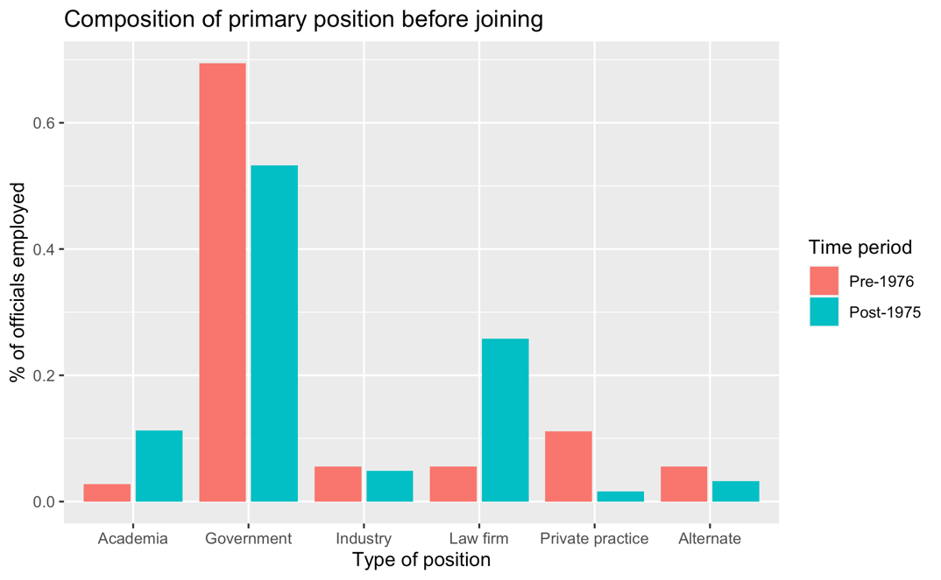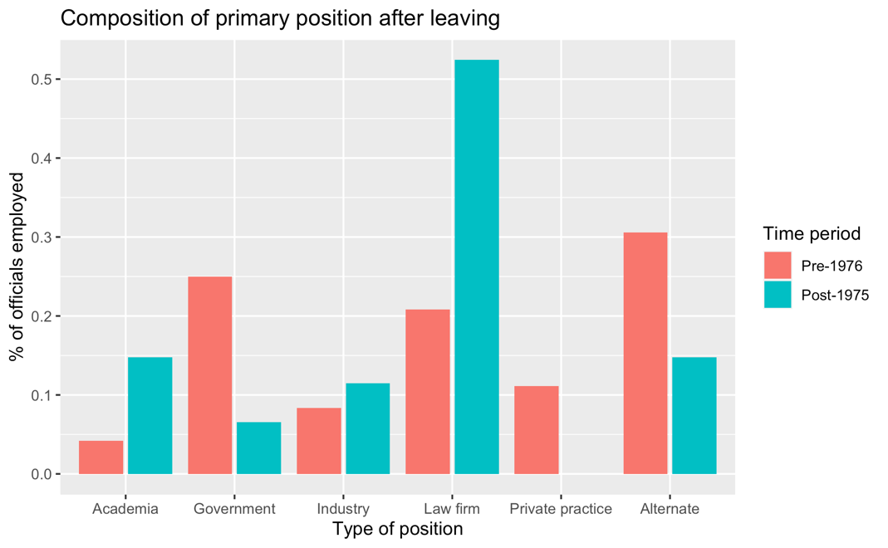

Source: Multiple varied sources

Understand leadership incentives paints only a partial picture, as the FTC and DOJ depend on a large body of civil servants to carry out their functions. We initially hoped to see whether civil servants revolved out of government and into private-sector jobs at an increasing rate like their leaders. However, we have been unable to find relevant and reliable data on tenure length and post-government positions for agency staff. As a second-best approach, we look at changes in their *incentives* to leave government posts for the private sector. To do so, we look at the differential in salaries between a similar position in government and in private practice. The greater that differential, the more difficult it will be for government officials to resist the lure of the private sector.

Figure XXX below tracks the compensation over time of several public employment positions, comparing it to the average compensation per equity partner of the top-100 US law firms and to the median cost of houses sold in the Washington D.C. area, where most staffers reside. For comparison, we also add data on first-year associate pay in top-tier law firms. This number is presented both adjusted solely for inflation and adjusted for inflation and for GDP growth.

Figure XXX: Real Salary in Constant 2011$ for lawyers in the public and private sector

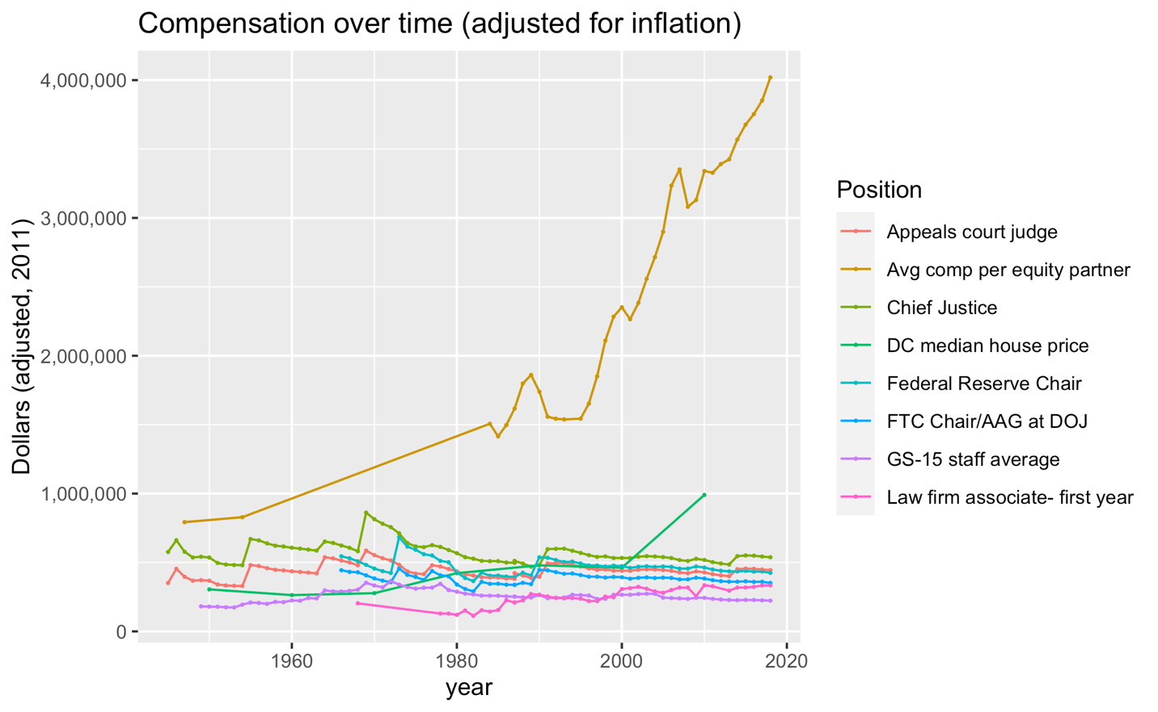

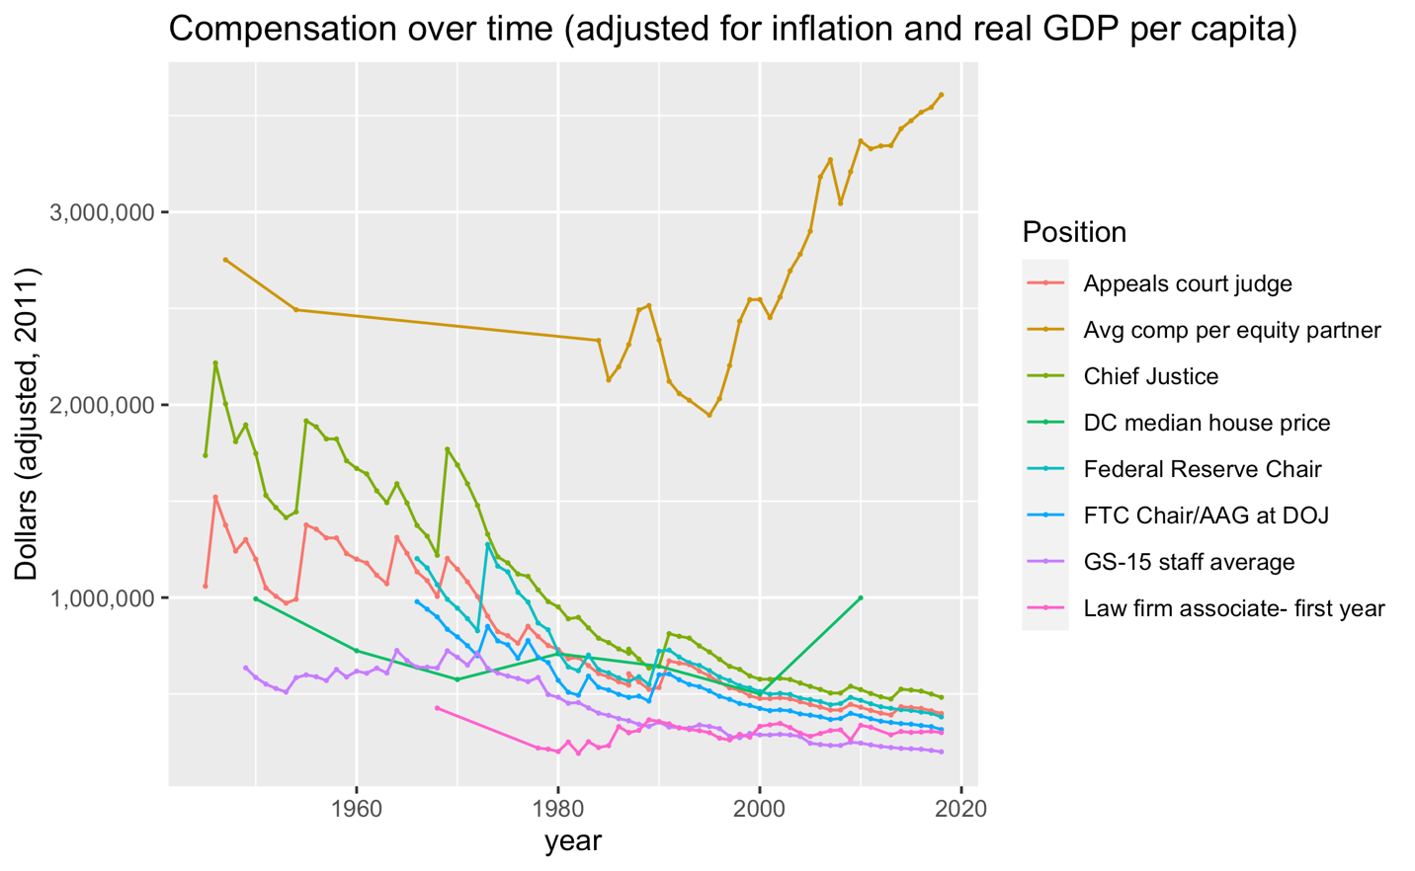

As the figures demonstrate, the periods of strong antitrust enforcement (pre-1975/1980) are directly correlated with a significantly lower salary differential between an equity partner in a law firm and an FTC or DOJ staff member than nowadays.[116] Indeed, in the 1960s a partner at a top law firm was earning roughly twice as much as an FTC chair. In the 1980s, this number rose to 5 times. Nowadays, it is 10 times. The gap is equally impressive when compared to the median cost of houses sold in the D.C. area, which sky-rocketed after the 2000s, significantly increasing the cost of living for public servants in this area. Even the premium against first-year associates—who are usually fresh out of law school—has risen significantly over this period, from XXXX to XXXXX.

It is hard to precisely quantify what the widening of this public employment premium means for the quality of work as well as the strength and type of enforcement actions pursued by the FTC and the DOJ. That said, it seems plausible that the growing salary differential translates into a shorter tenure at the government agencies, and that means a constant loss of experience and expertise, which is transferred from the government to the private sector. Recent anecdotal evidence has also indicated a growing revolving door between the agencies’ technical staff and the companies they were previously overseeing.[117]

In a way, the lag in staff compensation versus private employment just reflects a general lack of resources for antitrust enforcers. Indeed, when accounting for GDP Growth, the combined budget of the FTC and the DOJ is lower now than during peak enforcement.

Figure XXXX: Budgets of the FTC and the DOJ adjusted for inflation and GDP Per Capita Growth – in constant 1984$

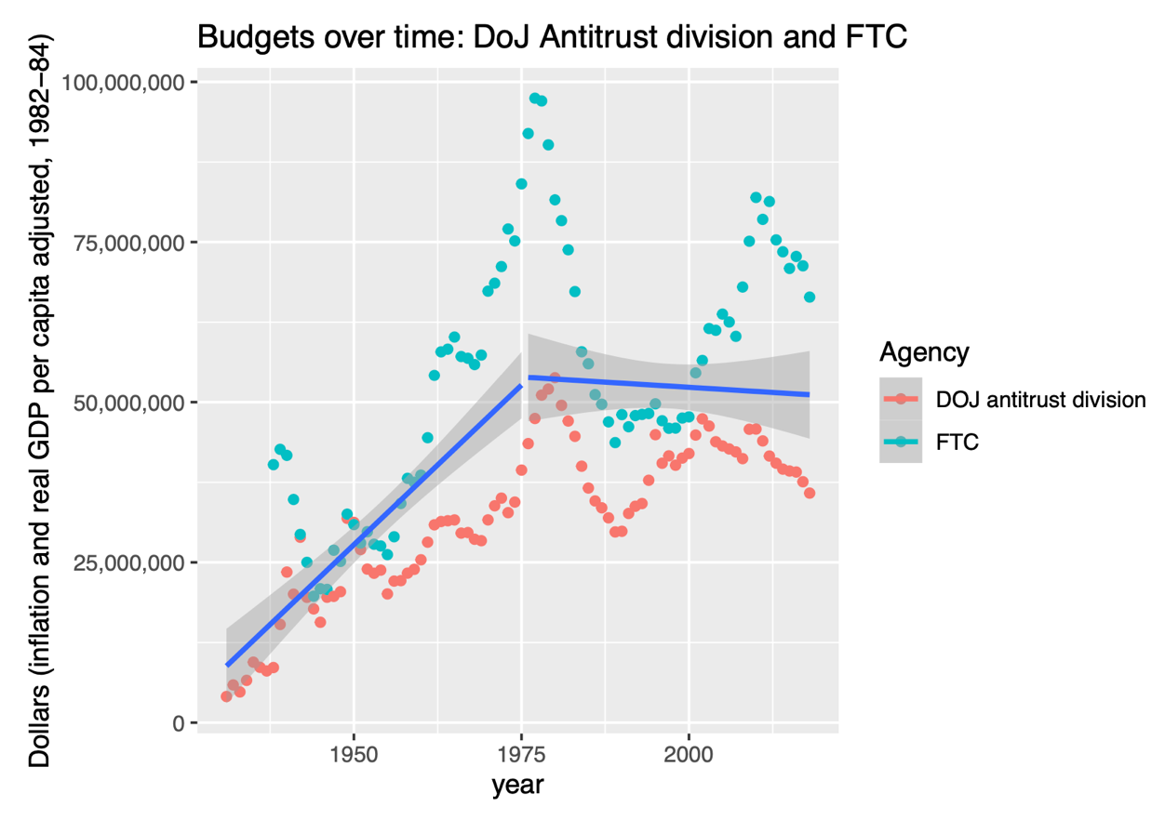

[ADD INFORMATION ON BUDGET COMPOSITION UNDER APPROPRIATIONS/FILING FEES]

Antitrust enforcement, however, has become significantly more expensive with the rise in cases trialed under the rule of reason and the need for economic modeling over the past decades.[118] This means that agencies have had to dedicate a growing share of their budget to each litigation, even if overall enforcement is falling. The decline in the number of staff positions adjusted per GDP over the past decades is even more impressive, as shown by FTC data below.

Figure XXXX: Real GDP for FTC Employee – 1929-2013 (Billions of 1996$)

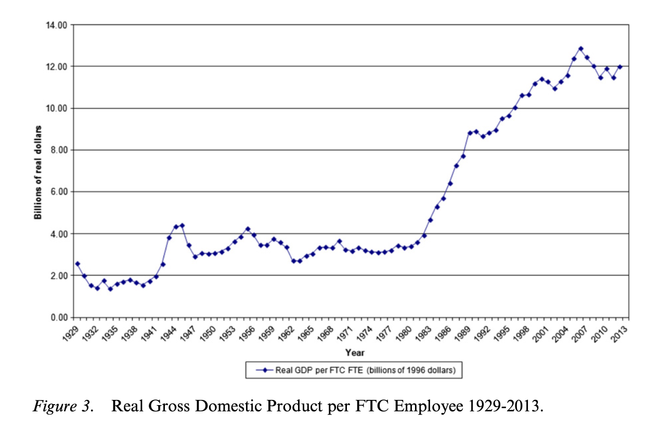

Source: Paul A. Pautler, “A History of the FTC’s Bureau of Economics,” in *Healthcare Antitrust, Settlements, and the Federal Trade Commission* (Emerald Publishing Limited, 2018).

The work of these agencies has also been undermined by other, non-antitrust-related legislation. For example, for decades the FTC Bureau of Economics conducted a series of so-called 6(b) and other studies where the agency requested information from private parties and issued encompassing reports on the competitive status of many sectors of the US economy. However, the number of such studies greatly declined after the 1980s (and in particular after the 1990s), as the economics staff of the FTC was more than halved—from 204 in 1981 to 89 in 1990—with the remaining personnel being allocated to the increasing workload of economics analysis in merger review and litigation support.[119] This in part also reflected severe limitations to the FTC’s ability to gather data due to the requirements of the Paperwork Reduction Act of 1980. This statute requires most Federal agencies to obtain special authorization from the Office of Information and Regulatory Affairs (OIRA), part of the Office of Personnel Management (OMB), whenever they request information from a large number of private parties. The approval process is so burdensome the government itself estimates it takes between six to nine months per request.[120] While it was not directly targeting anti-monopoly studies—already in decline at the time—the act was a final act to further weaken industry studies relying on private data.

In a summary, the weakening of antitrust enforcement that takes place after the second half of the 1970s is correlated with: (i) an explosion in the revolving door between agency leadership and the companies they are supposed to oversee; (ii) a major increase in the salary differential between private and public employees, likely leading to a growing revolving door between the agencies’ technical staff and private companies as well as fewer incentives for highly-qualified staff to join the agencies in the first place; (iii) a curtailment in the amount of resources available for both agencies to perform their role, in particular if considering the economic growth for the period; this while (iv) enforcement itself became much more expensive because of the rise in the rule of reason and the need for economic evidence in general, meaning the resources would have needed to go up for enforcement to stay constant; and (v) the imposition of non-antitrust related legal and other restrictions that limited the agencies’ ability to properly perform their work.

### Part III.B.3. Changes taking place at the Judiciary concomitantly to the weakening process

Grasping the motivation behind judicially-driven legal changes to antitrust law is challenging because the judiciary is designed to be insulated from direct pressure by private interests such as companies or associations.[121] Judges are appointed for life, receive a reasonable salary (even if this salary has been decreasing significantly in per-capita, real terms, as figure XXX above shows) and there is little evidence of revolving doors involving the federal judiciary. In addition, as we stated in our theoretical framework of Part II, changes in policy promoted by experts may still be democratically accountable and in the interest of the public, particularly so if these officials have been appointed specifically for that purpose. Therefore, a natural next step in our inquiry is to understand if federal judges have been appointed for their views on antitrust and, if not, where their views may have come from.

Figure XXX below compiles and analyzes all mentions of “antitrust” and “monopoly”[122] during the direct Q&A session with nominees to the US Supreme Court since the 1930s.

Antitrust was generally a non-topic in Supreme Court nomination hearings until the rejection of Robert Bork by a 58-42 vote in October 1987. During the nomination process, Bork was extensively challenged on his antitrust views, which many saw as dangerous and extreme. For example, Democratic Senator Metzenbaum from Ohio repeatedly rejected Bork’s views of antitrust enforcement. During Bork’s nomination, Metzenbaum stated: “I am concerned, Judge, as to what assurance can you give us that the antitrust laws will be enforced and consumers protected if you should become a member of the Supreme Court? (…) [t]he fact is, you would accept total concentration of economic power in just a couple of companies, maybe three, depending upon which day you were writing, and I am not questioning that point. But the point that bothers me is, competition is so vital to this free enterprise system, as I said earlier, and if we were to follow your line of reasoning there will not be any competition in this country because two companies will not effectively compete against each other. It will sort of be a laissez-faire approach where they will let each do their own thing.” Bork also received strong pushback from Republican Senator Specter from Pennsylvania for his apparent disregard of Congressional intent to ensure strong enforcement of the antitrust laws. Bork was ultimately rejected by a bipartisan majority. While antitrust was not the main reason for his rejection—his role in the Watergate investigation and his views on abortion played a more important role[123]—antitrust was covered at length and contributed to his depiction as an ideological extremist.

After Bork, antitrust enforcement was a (minor) topic in all judicial nominations. The same pattern found in presidential and Congressional documents, however, remains: whenever antitrust enforcement was mentioned, the mention was usually positive, and mentions to monopoly were always negative. With few exceptions, most nominees affirmed that they have never carefully analyzed antitrust law nor hold strong opinions on it, evading most direct questions. A good example is Justice Scalia’s answer to a question by Senator Thurmond of South Carolina on whether Courts were correctly considering economic analysis in antitrust law:

Senator, antitrust law has never been one of my fields. Indeed, in law school, I never understood it. I later found out, in reading the writings of those who now do understand it, that I should not have understood it because it did not make any sense then. As to whether the Court has—so I really am in no position. All I can tell you is hearsay, Senator, from those who follow the field. I do understand that the rules have changed in recent years, and that the Court is applying the principles and the data that economists have accumulated over the years regarding the sensible application of the antitrust laws. But I have not had a single antitrust case since I have been on the D.C. Circuit. And I have not complained about that, either*.*

Yet, whenever nominees expressed an opinion, it was generally in favor of stronger enforcement and the protection of small businesses. For example, Justice Sandra O’Connor recognized the key role antitrust plays in eliminating monopolies and protecting small businesses;[124] so did Justice David Souter, who further affirmed the key role of antitrust in preventing the consolidation of economic power;[125] which was echoed by Justice Thomas;[126] Justice Ginsburg;[127] and Justice Kagan.[128] Justice Roberts also defended the importance of strong antitrust enforcement, including private enforcement.[129] There were two exceptions. Justice Breyer affirmed that while strong enforcement is important, antitrust is all about getting lower prices for consumers;[130] Justice Gorsuch discussed the role of economics in helping antitrust prevent deadweight loss.[131] Even they, though, praise strong antitrust enforcement. In general, all questions come from Senators asking the nominees to protect strong enforcement and enact stricter antitrust laws while on the Court, and none face strong pushback by the nominees. In other words, the evidence from the confirmation hearings is consistent with the evidence from the legislative and political record that there was no direct political mandate to reduce antitrust enforcement.

To be added here: analysis of relevant Supreme Court Decisions in antitrust

* List of key Supreme Court decisions that weakened antitrust enforcement with analysis of: (i) who are they key votes; (ii) where justices are trained/what is their antitrust profile (check and Code CV’s starting in the 1950’s); (iii) who they cite in terms of doctrine
* Explore data on endorsements from the NYTimes, WSJ and the ACC (Link endorsements with Eric’s paper with Lee Epstein)

What did change was the overall profile of the Court itself, which became much more economically conservative and generally pro-business after the approximate 1975 break in antitrust enforcement. This is demonstrable using an analysis of pro-business rulings as coded by the Epstein, Landes and Posner article.[132] In particular, the overall mean pro-business votes in the pre-1975 high antitrust enforcement era was around 40%, rising to 48% in the post-1975, low enforcement era. One can state that this was simply the result of more Republican appointees in the period-something that reflects the overall numbers.[133] However, this pattern holds for both Democratic and Republican nominees, albeit in different magnitudes: Democratic nominees’ mean votes in favor of business grow from 35% to 38% before and after 1975, while Republican nominees’ pro-business votes increase from 43% to 52% between both periods. The figures are even more impressive if considering only Epstein, Landes and Posner’s New York Times data for the most important cases when mean numbers rise from 38% to 53% between high and low-enforcement periods; with the difference between Democratic nominees growing from 33% to 43%, and Republican nominees from 42% to 57% before and after 1975.

Table XXXX: Supreme Court Business-Friendly Profile (1946-2011)

| **Era** | **Mean of business-friendliness score** | **Mean of business-friendliness score on NYT cases** |
| --- | --- | --- |
| high enforcement (pre-1975) | 0.3931667 | 0.3812778 |
| low enforcement (post-1975) | 0.4788000 | 0.5278000 |

| **Era/party** | **Mean of business-friendliness** | **Mean of business-friendliness score on NYT cases** |
| --- | --- | --- |
| Democrat – high enforcement (pre-1975) | 0.3468750 | 0.3337500 |
| Democrat – low enforcement (post-1975) | 0.3810000 | 0.4300000 |
| Republican – high enforcement (pre-1975) | 0.4302000 | 0.4193000 |
| Republican – low enforcement (post-1975) | 0.5207143 | 0.5697143 |

Source: authors’ calculations, using data from Lee Epstein, William M. Landes, and Richard A. Posner, “How Business Fares in the Supreme Court,” *Minn. L. Rev.* 97 (2012): 1431.

This increasing business-friendliness of the courts took place at the same time, and likely as a result of, increased business attention and influence over the appointments and performance of the US judiciary. Starting in the 1970s, business groups poured money into law and economics research and conservative legal networks like the Federalist Society, with the goal of amplifying business influence and impact on the judiciary as well as the larger intellectual culture.[134] As Lewis Powell, then a corporate lawyer, wrote in a Memorandum to the American Chamber of Commerce, “American business ‘plainly is in trouble’; the response to the wide range of critics has been ineffective, and has included appeasement; the time has come – indeed, it is long overdue- for the wisdom, ingenuity and resource of American business to be marshaled against those who would destroy it.”[135] Two months later Powell was appointed to the Supreme Court by President Nixon. His nomination did not feature any mention of antitrust enforcement, but Powell would solidify a majority against strong antitrust enforcement on the Court.

Business influence would extend to attempts to influence judges in other ways. A paper by Ash et al. documents the role of various judicial training programs that promoted Chicago school ideas on antitrust law. The paper provides evidence that appeals court judges who attended a business-sponsored, stylized “law and economics” training (the Manne Program) that mostly includes lessons based on Chicago School theories become significantly more likely to vote in favor of lax antitrust enforcement, though a small sample prevents the authors from having clear identification for all samples and specifications.[136] These findings, however, do not include Supreme Court Justices, as only Justice Ruth Bader Ginsburg attended the program. In a separate analysis, Sying Cao finds a statistically significant and economically meaningful relationship between district judges’ economic sophistication (measured by the use of economic terms in decisions and previous economics education) and pro-business rulings (a major part of them being antitrust cases).[137] However, her analysis does not find a statistically significant impact for the Manne program in addition to judges’ previous knowledge and exposure to law and economics more generally. Cao attributes the conflicting results to either a selection effect of district judges who attended the program in the first place (versus circuit court judges in Ash et al.) or to sample restrictions that make the articles somewhat hard to directly compare (Cao lacks specific attendance data for judges for a pivotal period between 1976 and 1986).[138]

To summarize, all of these data and findings suggest three things. First, the evidence from the confirmation hearings and other associated work is consistent with the evidence from the legislative and political record: there was no direct public support for a reduction of antitrust enforcement. Whatever the real views of the nominees, they clearly learned a lesson from the Bork nomination, which is that opposition to antitrust enforcement is politically unpopular. Second, there was also no public, democratically tinged endorsement by the nominees, the president, or the Senate that the Supreme Court would or should use its power to weaken antitrust law. Third, there was, however, a significant shift in the profile of the Supreme Court and lower courts, which became significantly more pro-business after 1975. This is in part reflected by the rise of the law and economics movement, which itself was partially sponsored by business interests.[139]

# Part IV. Taking stock: a death by a thousand cuts

Under development and tentative

We have shown that the relaxation of antitrust enforcement since the mid-1970s was not the result of a popular mandate, but the outcome of technocratic decisions. Technocratic decisions are not necessarily bad. A possible view is that the public either underestimates the benefits of corporate scale, or is too ambivalent about large corporations to be able to provide consistent policy guidance to the government. In an effort to appease the public, Congress has used broad language in statutes that would, if taken literally, disrupt the economy and undermine economic growth, at everybody’s cost. By necessity, judges and regulators have imposed more stringent standards that reflect economic realities. Even many liberal or left-leaning economists seem to adopt this position.[140]

Ironically, this Chicago view is in tension with another contribution of the Chicago School: public choice. Public choice analyzes policy decisions as the result of the influence of interest groups. As applied to antitrust laws, the Chicago public choice view suggests that business interests that benefited from weaker antitrust laws were able to influence regulators and judges.

This influence took many possible forms. Under the revolving-door hypothesis, the business world offered jobs to former regulators, and these offers became increasingly attractive thanks to the skyrocketing compensation in private law firms and the stagnation of salaries in government jobs. Regulators hoping to secure these jobs use their powers to please rather than restrict the regulated industry. The growth in law firm partner’s salaries is somewhat of an exogenous shock, reflecting in part outsized returns for “superstar” workers that can be found in other areas as well.[141]

Another hypothesis is that interest groups pressured Congress but behind the scenes. Afraid of a frontal assault on antitrust law, which could have riled the public, interest groups exerted influence through the budgetary process. While this influence did have to survive democratic pressures—budgets are approved by Congress—it is hard to argue that the general public is directly engaged in budgetary allocation decisions to the FTC and the DOJ, so this is a very weak form of accountability.

A third hypothesis is that the regulatory agencies lost their best people to the industry they were trying to regulate, losing experience and expertise in the process, and putting them at the mercy of better-funded businesses fortified by cutting edge legal expertise on the inner workings of the regulators. This would be a process similar to what has been documented for the prosecution of white-collar financial crime by the Justice Department, which underwent a constant process of institutional weakening and of potential conflicts of interest that tamed much of its enforcement and prosecutorial capacity.[142] As regulators lost experience and expertise, they relied more heavily on outside expertise, and became vulnerable to epistemological capture by interests groups who funded and promoted economic theories that opposed antitrust, while ideas in economics more favorable to antitrust languished in obscurity.

The political economy story for the judiciary is more complex. Judges were likely influenced by intellectual developments beginning with the Chicago school. If this is the major reason, a battle of ideas took place in academia and the judiciary, acting from good motives to promote the public interest, were influenced by the winners. The decline of antitrust enforcement was simply the triumph of technocracy. We think there may be some truth to this view, but it also has several flaws. The Chicago school took the antitrust community by storm but by the 1980s a significant backlash had developed. While post-Chicago ideas that mostly urged stronger antitrust enforcement would play a role in some cases, they have not had the impact that one would expect if the judiciary was merely responding to the best academic work—some form of post-Chicago School would have had to strongly permeate, and it did not.

A more credible account is a combination of the technocratic triumph of the Chicago School, combined with both epistemological capture and the Chomsky effect. It starts with the growing tendency of Republican and conservative-leaning Democrats (like Bill Clinton) to nominate judges (and especially Supreme Court justices) sympathetic to business. As of 2011, five sitting justices (Alito, Roberts, Thomas, Kennedy, and Scalia) were in the top ten of the most pro-business justices since 1946.[143]

These justices knew little about antitrust, did not hold strong views on it nor had a strong mandate to weaken enforcement. Yet, they were disproportionately exposed to a set of ideas developed by independent scholars,[144] but that businesses helped promote. In doing so, businesses gave these ideas a sheen of legitimacy that went beyond their actual prevalence on the academic community (in particular after the 1980s). A kind of intellectual-legal culture arose that influenced judges while critics were unable to make headway, in part because they were fighting these powerful and now well-organized business interests.

There remains a final question, which is why the anti-monopoly sentiment dissipated in the 1970s in both political parties and in the public at large. There are two (non-mutually exclusive) explanations. The first is that antitrust had been a victim of its own success: thanks to antitrust enforcement, business was significantly less concentrated in the 1960s. Large companies were also subject to regulation. So people may have lost their fear of concentrated economic power because concentrated economic power was indeed less of an issue. Second, following the decline in economic growth experienced during the 1970s, the public’s support for pro-growth policies increased. In this context, business interests were able (rightly or wrongly) to convince the public that lax antitrust enforcement would be pro-growth.

Regardless of the cause, the dissipation of public support for antitrust led to a kind of regulatory entropy: without continuing public pressure, regulators became cautious and increasingly susceptible to the blandishments of business. There is a significant difference, however, between the first and the second view. According to the first, the decline of antitrust enforcement is not entirely an interest-group story. It reflects popular opinion as well even if Congress did not weaken antitrust statutes (though it did reduce enforcement budgets for the FTC and the Department of Justice). Indeed, one might argue that regulators and judges were themselves being responsive to public opinion. According to the second, however, the story is one of a diffuse and unorganized public unable to defend its interests from powerful interest groups.

# Conclusion

[to come]

**NOTES:**

[We need to work on this section, and I’m out of time for now. But a few points. (1) the salary differential reflects something like an exogenous shock; it has nothing to do with the incentives of interest groups, or a conscious decision by regulators or anyone else to weaken antitrust enforcement. It’s just not an interest group story. (2) By contrast, the reduction of resources for agencies is a decision—by Congress, who we say reflects the public interest. So this complicates our story. Maybe interest groups have given up trying to get the law changed—that would meet political resistance—but have figured out that they can reduce antitrust enforcement in a less transparent way by working through the budget. We can make this claim just as speculation, or we could see if we can find evidence for it. (3) Finally, I don’t understand what is going in the remainder of this section. There seems to be a mismatch between figures and text, I’m not sure.]

To what extent this is just selection? To what extent does treatment through exposure is important as well?

Academia, etc. allows you to dress-it-up better and do not show simply the selection in the judiciary.

Allows you to swing votes, convince lower courts, convince the public, etc.

1. We would like to thank Sima Biondi for superb research assistance.
2. See Part I, below.
3. See for example, Robert Pitofsky, *How the Chicago School Overshot the Mark: The Effect of Conservative Economic Analysis on US Antitrust* (Oxford University Press, 2008).; Lina Khan, “Amazon’s Antitrust Paradox,” *The Yale Law Journal* 126, no. 3 (2017): 710–805. at 737.
4. See, for example, Amit Zac, “Economic Inequality and Competition Law: A Comparative Analysis of the USA Antitrust Model,” *Available at SSRN*, 2020. and part I, below.
5. For example, Americans’ confidence on big business versus has fluctuated overtime, currently being at one of this historical lows. See Gallup Inc, “Gallup Pools - Big Business,” Gallup.com, July 2021, https://news.gallup.com/poll/5248/Big-Business.aspx.. This decrease has been particularly acute when tech companies are concerned—with most of the public wanting regulation—but applies across the board.
6. Vivek Ghosal, “Regime Shift in Antitrust Laws, Economics, and Enforcement,” *Journal of Competition Law and Economics* 7, no. 4 (2011): 733–74.
7. In chained 2012 dollars - See <https://fred.stlouisfed.org/series/GDPC1>
8. From Ghosal, “Regime Shift in Antitrust Laws, Economics, and Enforcement.”
9. Ghosal. at 770.
10. Reza Rajabiun, “Private Enforcement and Judicial Discretion in the Evolution of Antitrust in the United States,” *Journal of Competition Law and Economics* 8, no. 1 (2012): 187–230.
11. See Spencer Smith, “The Indirect Purchaser Rule and Private Enforcement of Antitrust Law: A Reassessment,” *Journal of Competition Law & Economics*, 2021.
12. Rajabiun, “Private Enforcement and Judicial Discretion in the Evolution of Antitrust in the United States.” at 215-16.
13. See XXXXXX.
14. Michael Kades, “The State of US Federal Antitrust Enforcement,” *Washington: Washington Center for Equitable Growth*, 2019, https://equitablegrowth.org/research-paper/the-state-of-u-s-federal-antitrust-enforcement/?longform=true.
15. Rajabiun, “Private Enforcement and Judicial Discretion in the Evolution of Antitrust in the United States.”
16. Kades, “The State of US Federal Antitrust Enforcement.”
17. Alex Kantrowitz, “‘A Breathtaking Constraint on Capacity’: Internal FTC Memo Announces Major Cuts Ahead of Tech Giant Action,” n.d., https://bigtechnology.substack.com/p/a-breathtaking-constraint-on-capacity.
18. Germán Gutiérrez and Thomas Philippon, “How EU Markets Became More Competitive than US Markets: A Study of Institutional Drift,” 2018.
19. Gustavo Grullon, Yelena Larkin, and Roni Michaely, “Are US Industries Becoming More Concentrated?,” *Review of Finance* 23, no. 4 (2019): 697–743.
20. David Autor et al., “Concentrating on the Fall of the Labor Share,” *American Economic Review* 107, no. 5 (2017): 180–85.
21. Matias Covarrubias, Germán Gutiérrez, and Thomas Philippon, “From Good to Bad Concentration? US Industries over the Past 30 Years,” *NBER Macroeconomics Annual* 34, no. 1 (2020): 1–46.
22. Esteban Rossi-Hansberg, Pierre-Daniel Sarte, and Nicholas Trachter, “Diverging Trends in National and Local Concentration” (National Bureau of Economic Research, 2018).
23. Harold Demsetz, “Industry Structure, Market Rivalry, and Public Policy,” *The Journal of Law and Economics* 16, no. 1 (1973): 1–9.
24. Jan De Loecker, Jan Eeckhout, and Gabriel Unger, “The Rise of Market Power and the Macroeconomic Implications,” *The Quarterly Journal of Economics* 135, no. 2 (2020): 561–644.
25. Susanto Basu, “Are Price-Cost Markups Rising in the United States? A Discussion of the Evidence,” *Journal of Economic Perspectives* 33, no. 3 (2019): 3–22.
26. Simcha Barkai, “Declining Labor and Capital Shares,” *The Journal of Finance* 75, no. 5 (2020): 2421–63.
27. Germán Gutiérrez and Thomas Philippon, “Declining Competition and Investment in the US” (National Bureau of Economic Research, 2017).
28. Gutiérrez and Philippon.
29. Grullon, Larkin, and Michaely, “Are US Industries Becoming More Concentrated?”
30. Barkai, “Declining Labor and Capital Shares.”
31. Vanessa Alviarez, Keith Head, and Thierry Mayer, “Global Giants and Local Stars: How Changes in Brand Ownership Affect Competition,” 2020.
32. Thomas G. Wollmann, “How to Get Away with Merger: Stealth Consolidation and Its Real Effects on US Healthcare” (National Bureau of Economic Research, 2020).
33. Mara Faccio and Luigi Zingales, “Political Determinants of Competition in the Mobile Telecommunication Industry,” *Review of Financial Studies (Forthcoming)*, 2021.
34. David Autor et al., “The Fall of the Labor Share and the Rise of Superstar Firms,” *The Quarterly Journal of Economics* 135, no. 2 (2020): 645–709.
35. Autor et al. at 645.
36. Wollmann, “How to Get Away with Merger: Stealth Consolidation and Its Real Effects on US Healthcare.”
37. Alviarez, Head, and Mayer, “Global Giants and Local Stars: How Changes in Brand Ownership Affect Competition.”
38. Colleen Cunningham, Florian Ederer, and Song Ma, “Killer Acquisitions,” *Journal of Political Economy* 129, no. 3 (2021): 649–702.
39. Bruce A. Blonigen and Justin R. Pierce, “Evidence for the Effects of Mergers on Market Power and Efficiency” (National Bureau of Economic Research, 2016).
40. Grullon, Larkin, and Michaely, “Are US Industries Becoming More Concentrated?”
41. Barkai, “Declining Labor and Capital Shares.”
42. Drew Desilver, “For Most Americans, Real Wages Have Barely Budged for Decades,” *Pew Research Center* (blog), August 7, 2018, https://www.pewresearch.org/fact-tank/2018/08/07/for-most-us-workers-real-wages-have-barely-budged-for-decades/.
43. Luigi Zingales, “The Political Limits of Economics,” in *AEA Papers and Proceedings*, vol. 110, 2020, 378–82.
44. George J. Stigler, “The Theory of Economic Regulation,” *The Bell Journal of Economics and Management Science*, 1971, 3–21.
45. Filippo Lancieri and Luigi Zingales, “Economic Regulation After George Stigler,” *ProMarket* (blog), April 14, 2021, https://promarket.org/2021/04/14/economic-regulation-after-george-stigler/.
46. Sam Peltzman, “Toward a More General Theory of Regulation,” *The Journal of Law and Economics* 19, no. 2 (1976): 211–40.
47. Gary S. Becker, “A Theory of Competition among Pressure Groups for Political Influence,” *The Quarterly Journal of Economics* 98, no. 3 (1983): 371–400.
48. See Mancur Olson, *The Logic of Collective Action: Public Goods and the Theory of Groups*, 2nd ed. (Cambridge, MA: Harvard University Press, 1971).
49. See Filippo Lancieri, “Narrowing Data Protection’s Enforcement Gap,” *Maine Law Review* 74, no. 1 (2022). at 32-33.
50. Exceptions exist, such as when they plan to run for office in a later period.
51. For example, Judges tenured for life are more independent from Governmental priorities than serving-at-will technocrats; stricter or weaker anti-corruption or anti-conflict of interest rules impact the prospects of future employment, etc.
52. See Philippe Aghion and Jean Tirole, “Formal and Real Authority in Organizations,” *Journal of Political Economy* 105, no. 1 (1997): 1–29. at 3 (outlining reasons why one would delegate decision-making power to a lower body if more expert/better informed); Filippo Lancieri and Caio Mario Pereira Neto, “Designing Remedies for Digital Markets: The Interplay between Antitrust and Regulation,” *Journal of Competition Law & Economics* Forthcoming (2021), https://papers.ssrn.com/sol3/papers.cfm?abstract_id=3704763. (discussing reasons why a specialized regulator may be better equipped than a general enforcer to handle certain aspects of policymaking in digital markets).
53. Jesse Drucker and Danny Hakim, “How Accounting Giants Craft Favorable Tax Rules From Inside Government,” *The New York Times*, September 19, 2021, sec. Business, https://www.nytimes.com/2021/09/19/business/accounting-firms-tax-loopholes-government.html.
54. Ivana Katic and Jerry W. Kim, “Caught in the Revolving Door: Firm-Government Ties as Determinants of Regulatory Outcomes,” in *Academy of Management Proceedings*, vol. 2013 (Academy of Management Briarcliff Manor, NY 10510, 2013), 12899.
55. Cass R. Sunstein, “Stigler’s Interest-Group Theory of Regulation: A Skeptical Note,” *ProMarket* (blog), April 16, 2021, https://promarket.org/2021/04/16/george-stigler-theory-regulation-capture-cass-sunstein/. (explaining the term); Lancieri, “Narrowing Data Protection’s Enforcement Gap.” (discussing its application to data protection policy).
56. Aghion and Tirole, “Formal and Real Authority in Organizations.”, at 2-3.
57. Luigi Zingales, “Preventing Economists Capture,” in *Preventing Regulatory Capture: Special Interest Influence and How to Limit It* (Cambridge University Press, 2013).;
58. Marianne Bertrand et al., “Hall of Mirrors: Corporate Philanthropy and Strategic Advocacy” (National Bureau of Economic Research, 2018).; Daisuke Wakabayashi, “Big Tech Funds a Think Tank Pushing for Fewer Rules. For Big Tech.,” *The New York Times*, July 24, 2020, sec. Technology, https://www.nytimes.com/2020/07/24/technology/global-antitrust-institute-google-amazon-qualcomm.html.; Rob Davis and Toni Schick, “What Happened When a Public Institute Became a De Facto Lobbying Arm of the Timber Industry,” ProPublica, August 4, 2020, https://www.propublica.org/article/what-happened-when-a-public-institute-became-a-de-facto-lobbying-arm-of-the-timber-industry.
59. Lancieri, “Narrowing Data Protection’s Enforcement Gap.”
60. Elliott Ash, Daniel L. Chen, and Suresh Naidu, “Ideas Have Consequences: The Impact of Law and Economics on American Justice,” *Center for Law & Economics Working Paper Series* 4 (2021).
61. Edward S. Herman and Noam Chomsky, *Manufacturing Consent: The Political Economy of the Mass Media* (Random House, 2010).
62. After his description of such process for the news media in Herman and Chomsky.
63. As Noam Chomsky explained when asked by a BBC journalist on whether he believed the journalist was self-censoring, “I am not saying you are self-censoring, I am saying that if you did not believe in what you believe, you would not be where you are”. Noam Chomsky, The Big Idea - Noam Chomsky Interview with Andrew Marr, February 1996, https://www.youtube.com/watch?v=GjENnyQupow. at 11’
64. As mentioned above, different market characteristics enable or hinder these dynamics, such as how concentrated the industry is and how aligned are the political interests of industry players, how disperse the group paying the rent is, how opaque is the rent payment itself, transaction costs in the political organization of dispersed agents, etc. See Lancieri, “Narrowing Data Protection’s Enforcement Gap.” at 32-33.
65. Lancieri. at 39.
66. For example, requiring regulators to propose rules and solicit public comment before formally issuing those rules forces interest groups to submit comments and data, putting opponents on alert, and allowing them to respond by marshalling evidence and making arguments of their own.
67. For example, a former PCAOB inspector hired by KPMG was able to provide the audit firm with advanced warnings of which engagements will be inspected. Securities and Exchange Commission, “Six Accountants Charged with Using Leaked Confidential PCAOB Data in Quest to Improve Inspection Results for KPMG,” sec.gov, June 2018, https://www.sec.gov/news/press-release/2018-6.
68. See Jody Freeman and Sharon Jacobs, “Structural Deregulation,” *Harvard Law Review, Forthcoming*, 2021.
69. See Andrei Shleifer, “George Stigler’s Paper on Regulation and the Rise of Political Economy,” *ProMarket* (blog), April 28, 2021, https://promarket.org/2021/04/28/george-stiglers-regulation-political-economy-capture/.
70. A possibly more important exception to this pattern of increasing antitrust liability and enforcement was a series of early New Deal statutes, including the National Industrial Recovery Act of 1933, which gave the federal government power to authorize and regulate cartels. But this short-lived experiment was a response to an economic emergency, and placed cartelization under the authority of the government, and so was not really an exception to the overall trend toward limiting the power of private corporations to collude or monopolized markets on their own.
71. See 15 U.S. Code § 6a.
72. Op. cit.
73. Andrew G. Howell, “Why Premerger Review Needed Reform-and Still Does,” *Wm. & Mary L. Rev.* 43 (2001): 1703. at 1703-04.
74. Howell. at 1704.
75. Frederick M. Rowe, “Political Objectives and Economic Effects of the Robinson-Patman Act: A Conspicuous US Antitrust Policy Failure,” *Zeitschrift Für Die Gesamte Staatswissenschaft/Journal of Institutional and Theoretical Economics*, no. H. 3 (1980): 499–509. at 500.
76. “Antitrust Commission Recommends Repeal of Robinson-Patman Act,” *NAW - National Association of Wholesale Distributors* (blog), December 2007, https://www.naw.org/advisory/antitrust-commission-recommends-repeal-robinson-patman-act/.
77. Roger D. Blair and Christina DePasquale, “‘Antitrust’s Least Glorious Hour’: The Robinson-Patman Act,” *The Journal of Law and Economics* 57, no. S3 (2014): S201–15. at S212.
78. Luigi Zingales “The Political Limits of Economics” American Economic Review, Vol. 110, May 2020, 378-82.
79. Currently, half of US States have such Statutes. See Smith, “The Indirect Purchaser Rule and Private Enforcement of Antitrust Law: A Reassessment.” at 652.
80. Antitrust includes both “antitrust” and “anti-trust”. Monopoly includes “monopoly”, “monopolies” and “monopolistic”. Some mentions to monopoly were removed when they did not relate to economic policies, such as “monopoly over violence”, etc. Equally, including “competition” and variants yields largely similar results, though these results are noisier because of many unrelated mentions to international competition with the USSR, fair competition in international trade, etc.
81. The analysis to this point does not yet include Presidential Executive Orders and Proclamations.
82. <https://www.presidency.ucsb.edu/documents/state-the-union-message-congress>
83. <https://www.presidency.ucsb.edu/documents/annual-message-the-congress-the-state-the-union-14>
84. <https://www.presidency.ucsb.edu/documents/annual-message-the-congress-the-state-the-union-7>
85. <https://www.presidency.ucsb.edu/documents/annual-message-the-congress-the-state-the-union-4>
86. <https://www.presidency.ucsb.edu/documents/address-before-joint-session-the-congress-reporting-the-state-the-union>
87. <https://www.presidency.ucsb.edu/documents/the-state-the-union-annual-message-the-congress-2> . Carter would go on to create a Commission to review antitrust laws and procedures, whose goal was to “suggest changes needed in laws and court procedures in order to expedite complex antitrust’ cases and make the remedies in those cases more effective.” See <https://www.presidency.ucsb.edu/documents/executive-order-12022-national-commission-for-the-review-antitrust-laws-and-procedures>
88. <https://www.presidency.ucsb.edu/documents/the-state-the-union-annual-message-the-congress-1>
89. We employed the same methodology as described in footnote XXXXXXX above.
90. <https://www.presidency.ucsb.edu/documents/1964-democratic-party-platform>
91. See <https://www.presidency.ucsb.edu/documents/republican-party-platform-1972>. The 1968 Republican Platform stressed “A new Republican Administration will undertake an intensive program to aid small business, including economic incentives and technical assistance, with increased emphasis in rural and urban poverty areas. In addition to vigorous enforcement of the antitrust statutes, we pledge a thorough analysis of the structure and operation of these laws at home and abroad in the light of changes in the economy, in order to update our antitrust policy and enable it to serve us well in the future.” See <https://www.presidency.ucsb.edu/documents/republican-party-platform-1968>
92. <https://www.presidency.ucsb.edu/documents/republican-party-platform-1980>
93. <https://www.presidency.ucsb.edu/documents/republican-party-platform-1988>
94. The 1992 Republican Party Platform stated that “We will modify outdated antitrust rules that prohibit hospitals from merging their resources to provide improved, cost-effective health care.”; the 1996 promised to “change anti-trust laws to let health care providers cooperate in holding down charges.” See <https://www.presidency.ucsb.edu/documents/republican-party-platform-1992> and <https://www.presidency.ucsb.edu/documents/republican-party-platform-1996>
95. See, for example, Daniel A. Crane, “Antitrust Antitextualism,” *Notre Dame Law Review* 96, no. 1 (2021): 1204. at xxxxx.
96. E.g., E.C. Knight. See Sawyer, Historical Perspective, p. 7.
97. Crane, “Antitrust Antitextualism.”
98. Illinois Brick; AGC. See Smith, “The Indirect Purchaser Rule and Private Enforcement of Antitrust Law: A Reassessment.”
99. Twombly.
100. Matsushita.
101. Sylvania, Leegin, Jefferson Parish and many others.
102. Brooke Group; Volvo Trucks
103. Brooke Group.
104. American Express. For a detailed account, see Caio Mario Pereira Neto and Filippo Lancieri, “Towards a Layered Approach to Relevant Markets in Multi-Sided Transaction Platforms,” *Antitrust Law Journal* 83, no. 2 (2020): 701.
105. American Colors.
106. AT&T / TimeWarner, and mergers generally.
107. Hanover Shoe. See Smith, “The Indirect Purchaser Rule and Private Enforcement of Antitrust Law: A Reassessment.”
108. Compare Aspen Skiing, Kodak and Trinko.
109. Apple v. Pepper.
110. E.g., Crane, “Antitrust Antitextualism.” others.
111. Shapiro, Hedgehog to Fox, p. 51.
112. For some we could not find reliable information, such as XXXXX.
113. The graphic below reports a 1975 breakpoint that is aligned with the estimations of structural breaks in enforcement described in Part I. However, the numbers do not change much if we adopt a 1980’s breakpoint.
114. Alternate includes everything not represented in the other categories, including retirement, death, work as a journalist, unclear and others. Law Firm describes major law firms while private practice describes mostly small law firms, but also cases where we cannot confirm which law firm the person joined after leaving government.
115. While we do not have time series data, the involvement of academics in consulting for antitrust defendants has received attention in recent years. Eisinger Jesse and Elliot Justin, “These Professors Make More Than a Thousand Bucks an Hour Peddling Mega-Mergers,” ProPublica, November 16, 2016, https://www.propublica.org/article/these-professors-make-more-than-thousand-bucks-hour-peddling-mega-mergers?token=66qLWQOC8-aKmhz5ZMZX7A6VtNhdKyrS. (Describing the impact and prevalence of economics professors doing consulting in antitrust litigation.); Rick Claypool, “75% of FTC Officials Have Revolving Door Conflicts With Tech Corporations and Other Industries,” Public Citizen, May 23, 2019, <https://www.citizen.org/article/ftc-big-tech-revolving-door-problem-report/>.
116. GS-15 is one of the highest paid positions a governmental employee such as an FTC or DoJ personnel may attain. The Federal Employees Pay Comparability Act of 1990 (FEPCA) introduced a Locality Pay Area Adjustment for certain geographic regions with a high cost of living, one of them being the Washington-Baltimore-Arlington region. This increases salaries in roughly 30%. Both figures present the base GS-15 schedule average, without the pay adjustment, as the data for partners is nation-wide. The conclusions hold even with the linear increase introduced by the FEPCA.
117. See Adam Janofsky and Matt Drange, “We Counted the FTC Employees Who Moved over to Tech. Is Reform Needed?,” Protocol, March 9, 2020, https://www.protocol.com/ftc-tech-hawley-revolving-door. (finding that between 2015-2019 at least 72 lawyers and other employees left the FTC to go work for private law firms and tech companies); Hal Singer, “As the Revolving Door Swings,” The American Prospect, July 17, 2020, https://prospect.org/api/content/65c2d248-c7b3-11ea-9581-1244d5f7c7c6/. (researching on LinkedIn and finding hundreds of former DoJ, FTC and Senate and House Judiciary Committees now working for Amazon, Google and Facebook).
118. Ramsi Woodcock, “The Hidden Rules of a Modest Antitrust,” *Forthcoming, Minn. L. Rev*, 2021.; Paul A. Pautler, “A History of the FTC’s Bureau of Economics,” in *Healthcare Antitrust, Settlements, and the Federal Trade Commission* (Emerald Publishing Limited, 2018).
119. Pautler, “A History of the FTC’s Bureau of Economics.” at 164-67. some reporting in particularly sensitive areas such as hospitals, oil and credit industries continued, but it mostly used publicly available data.
120. See <https://pra.digital.gov/clearance-process/>
121. And this may be consistent with a interest-group perspective of policy-making. See William M. Landes and Richard A. Posner, “The Independent Judiciary in an Interest-Group Perspective,” *The Journal of Law and Economics* 18, no. 3 (1975): 875–901.
122. Including anti-trust and variations of the radical “monopol” such as of the monopolies, monopolize, etc. as per the methodology explained in footnote XXX above.
123. Jonathan Fuerbringer, “Byrd Says Bork Nominiation Would Face Senate Trouble,” *The New York Times*, June 30, 1987, sec. U.S., https://www.nytimes.com/1987/06/30/us/byrd-says-bork-nomination-would-face-senate-trouble.html.
124. “Certainly I recognize that the object of the Sherman Act was to reduce or eliminate monopolies. To that extent, of course it has the effect of encouraging competition and encouraging smaller units to be in operation.”, in answer to question by Senator Metzenbaum on whether a key role of antitrust was the protection of small businesses.
125. “I also have been well educated by Senator Rudman over the years in the value of small business. Small business has no better friend than he has, and I think one of the lessons that I have ab sorbed from a long period of my professional lifetime with him, if I needed to absorb that from anyone else, is the importance of a degree of competition which will allow small business to emerge and allow for diversity in the American economy, which it is the object of the antitrust laws to secure, as much as that is possible.

     Senator KOHL. DO you agree, Judge Souter, that an important purpose of the Sherman Act is to protect against consolidation of economic power and make sure that consumers are not abused by companies engaged in monopolistic business practices?

     Judge SOUTER. There is simply no question about it, either as an historical matter or as a strictly legal matter, as one examines the precedents. The ultimate object of the system, it seems to me, has to be judged on its systemwide effects. I do not think the antitrust laws should even be seen as merely consumer laws or as anti-business laws, but as laws intended to assure a free and open and competitive economic system for everyone.”
126. “Judge THOMAS. Senator, I think that all of our efforts, including the antitrust laws, to keep a free and open economy, one in which there is competitiveness, where the smaller businesses can have an opportunity to compete, and where consumers can benefit from that—those efforts, including the antitrust laws, have been beneficial to our country from my standpoint.

     Senator KOHL. Judge, do you believe that an important purpose of the Sherman Act is to protect against consolidation of economic power to make sure that consumers are not charged high prices by large companies that have swallowed up their competition; that an important purpose of the Sherman Act is to protect against consolidation of economic power?

     Judge THOMAS. Yes, Senator.”
127. Judge GlNSBURG. Senator Metzenbaum, I think your recitation of the purposes of the antitrust law—to protect consumers, to protect the independent decision making of entrepreneurs—is entirely correct. I am pleased that you like my opinion in the *Michigan Citi- zens* (1989) case. It is a decision that I wrote. I think it gives the best picture of my views in this area. (…) You asked me if the only purpose of the antitrust law is efficiency. The cases indicate that the antitrust laws are focused on the interests of the consumer. There is also an interest in preserving the independence of entrepreneurs. I don't think the antitrust laws call into play only one particular economic theory. The Supreme Court made that clear in the *Kodak* (1992) case. But out of the context of a specific case, I can't say much more. No, I don't think efficiency is the sole drive.”
128. “[I] think on the one hand it is clear that antitrust law needs to take account of economic theory and economic understandings, but it needs to do so in a careful way and to make sure that it does o in a way that is consistent with the purposes of the antitrust laws, which is to ensure competition, which is, as you say, to be a real charter of economic liberty.”
129. Senator Kohl: Do you agree that government enforcement of antitrust law is crucial to ensuring that consumers are protected from anticompetitive practices, such as price fixing and illegal maintenance of monopolies?

     Judge ROBERTS. Yes, I do, Senator. In fact, when I was in private practice, one of the cases I handled was the Microsoft antitrust case on behalf of government officials, the States in particular. A number of States retained me to argue that case before the D.C. Circuit en banc. So I certainly appreciate the role of governments, both State and Federal, in enforcing the protections of the antitrust laws, because as you know, there is concurrent authority in that area, the Sherman Act, of course, on the Federal level and then what people call the ‘‘Baby Sherman Acts’’ on the State level. (…) I do think that the system established under the Sherman Act of private antitrust enforcement, and, of course, the opportunity to recover additional damages and attorneys’ fees and other aspects, has been an effective tool in enforcing the law.
130. The point that I would frequently make in those conversations is that if you are going to have a free enterprise economy, if you are not going to have the Government running everything, then you must have a strong and effective antitrust law. If you are not going to regulate airlines, you must have a strong antitrust law for airlines. 'Hie reason is that antitrust law is the policeman. Antitrust law aims, through the competitive process, at bringing about low prices for consumers, better products, and more efficient methods of production. (…) Those three things, in my mind, are the key to antitrust law and really a strong justification for an economy in which there are winners and losers, and some people get rich and others do not. The justification lies in the fact that that kind of economy is better for almost everyone, and it will not be better for almost everyone un- less the gains of productivity are spread. And the gains of productivity are spread through competition. That brings about low prices, better products, and more efficient methods of production. And that is what I think antitrust law is about, and that is what I think that policeman of the free enterprise system has to do. It is called protect the consumer.”
131. “Judge GORSUCH. Well, the real problem at the end of the day, I mean, you have a problem of lack of competition between competitors, and then of course that filters down to the consumer level. And what that yields are higher prices, and lower output, the dead weight loss to the economy, loss of production, and those are real harms. And the antitrust laws, as you know, were the original Federal regulatory regime. That was it for the national economy for a long time, and they are still vital and brilliant in their simplicity and design.”
132. Lee Epstein, William M. Landes, and Richard A. Posner, “How Business Fares in the Supreme Court,” *Minn. L. Rev.* 97 (2012): 1431. Epstein, Landes and Posner’s analysis cover the period from 1946 to 2011—also the period for the numbers discussed here.
133. Epstein, Landes, and Posner. at 1453.
134. See Steven M. Teles, *The Rise of the Conservative Legal Movement* (Princeton University Press, 2012). at xxxx; Amanda Hollis-Brusky, *Ideas with Consequences: The Federalist Society and the Conservative Counterrevolution* (Studies in Postwar American Po, 2015). at xxxx; and Matt Stoller, *Goliath: The 100-Year War Between Monopoly Power and Democracy* (Simon & Schuster, 2019). at xxxxx.
135.
136. Ash, Chen, and Naidu, “Ideas Have Consequences: The Impact of Law and Economics on American Justice.” at 30.
137. Siying Cao, “Quantifying Economic Reasoning in Court: Judge Economics Sophistication and Pro-Business Orientation,” 2021, https://drive.google.com/file/d/1U5tFHXqrcmNbCWOw5t7MqAcZ8BDMlMIN/view. at 45-46.
138. Cao. at 51-53.
139. As Justice Powell himself recognized, Universities and academic campuses represented “the single most dynamic source” of opposition to businesses’ interests, so that a priority would be helping staff and promote scholars and ideas that supported business interests. Powell, “Powell Memorandum: Attack on American Free Enterprise System.” at 12; 15-20.
140. See Carl Shapiro, Antitrust in Age of Populism.
141. [Add source]
142. Jesse Eisinger, *The Chickenshit Club: Why the Justice Department Fails to Prosecute Executives* (Simon and Schuster, 2017).
143.
144. The Olin foundation did extend grants to the Chicago Law School and the Law and Economic programs. Yet these grants pale in comparison to the millions of dollars granted by liberal foundations (like the Ford foundation, the Sloan foundation, the MacArthur Foundation, or – more recently—the Gates foundation). A more powerful incentive might have come from the lucrative consulting opportunities the application of law and economics to legal cases started to provide to economists. With the foundation of Lexecon in 1977, law and economic experts, critical to the traditional way antitrust was conducted, became in high demand. Demand generated its own supply. The peer-review process and control of the editorship of the main field journals did the rest entrenched this perspective in the field.